Subdivision Application Packet

(Including Annexation and Zoning Request Forms)
Adopted 07/21/09

Pages

- Cover Letter 2-3
- City of Dillon Application 4-8
- Fee Schedules (ALL FEES AND COSTS ARE NON-REFUNDABLE) 10-13
- Pre-Application Requirement (16-55-30 DMC) 14
- Application Requirements (16-85-45 DMC) 15-30
- List of Required Entities 17
- DEQ Application 19-30
- Annexation 32-36
- New Zoning 38-40
- Zoning Change 41-52
- Noxious Weeds 53-60

CITY OF DILLON SUBDIVISION PROCESS
This application packet has been prepared to assist you through the Pre-Application and Application process and help you achieve an organized subdivision submittal.

The Subdivision regulations should be reviewed carefully before submitting your request for the Pre-Application meeting with the Subdivision Administrator.

It is also suggested that you review the entire packet first before starting to fill in the application information. Unfortunately there is some information that may seem to be duplication but it is needed information for each element and must be included for correct review of each requirement.

Also included is the Subdivision Fee Schedule and Ordinance 406-1A, water and sewer development fees.

Public Hearings are required for Annexation, Subdivision Review and Zoning and will be held jointly when applicable by Montana Code Annotated.

The City of Dillon can only review subdivision projects within the municipal jurisdiction. If the property is not within the jurisdiction, is it in the one mile growth area as defined in the City of Dillon Growth Policy?

If the proposed project is within the one mile growth area, annexation and zoning must be accomplished for the City of Dillon to be the jurisdictional authority to do the subdivision review.

PRE-APPLICATION PROCESS:

For the Pre-Application Meeting review Section 16-55-25 DMC through 16-55-30 DMC of the regulations. Copies of these Sections are provided in this packet to assist as a checklist. When ready call the Subdivision Administrator to schedule your Pre-Application appointment.

The Subdivision Administrator will advise the applicant of development of the sanitation packet to submit to the Montana Department of Environmental Quality (DEQ) and a copy of the DEQ’s application is included in the packet.

Also required is Section 16-55-40 DMC, which requires a Subdivision Application within 180 days of the Pre-Application meeting or the process starts over.

APPLICATION PROCESS

Please place the City of Dillon Application and DEQ’s Application as the first documents in your submittal packet.

When all application elements are accomplished and all fees have been paid, the Subdivision Administrator will forward the applicants proposal to the Planning Board with the Subdivision Administrator Staff Report.

Twelve (12) copies of the Application, Preliminary Plat, and all supporting documents are needed.

A meeting will then be scheduled with the Planning Board for the Subdivider/Developer to present their project. The Planning Board meets on the 2nd and 4th Tuesday of each month.
If all information is complete the Subdivision Public Hearing will be scheduled.

After the Planning Board review and the Public Hearing, a Findings of Fact will be prepared and the project placed on the agenda of the City Council with the Planning Board recommendation for approval, approval with conditions or denial.

The property owner, Subdivider/Developer, if different and designated representative may be requested to attend hearings, planning board meetings and city council meetings to answer questions.

Also included in the packet are all documents that must be completed to submit for the Final Plat review and after approval must be filed with the Beaverhead County Clerk and Recorder. Twelve (12) copies of these documents are required.

The information provided in the packet is to assist you through the process. The Subdivision Administrator is your day-to-day contact and will answer your questions.

There are many requirements in the Subdivision Regulations and it is the responsibility of the Subdivider/Developer to review and comply with all the requirements.

Thank you and we hope you find this packet helpful.

Subdivision Administrator
City of Dillon
Phone: (406) 683-4245
Fax: (406) 683-6361
e-mail: operations@dillonmt.org

CITY OF DILLON
125 N Idaho St
Dillon, MT 59725
(406) 683-4245

Application No:

When the Application is received, an application number will be assigned.
Please include on upper right hand corner of all future paperwork.

DILLON SUBDIVISION APPLICATION

Date:

- Name of proposed subdivision
- Physical Address
- Legal Description:
Lot Block(s) Parcel:
Tract COS
Or Book Tax ID
Deeds in Sec. , T R Assessor Code
Metes & Bounds Perimeter Legal Description: (complete description must be attached to application)

Property Size(acres) Acres Fire Dist. No
School District
Current Covenants or Deed Restrictions attach to application.
Current Use
Agricultural Use

 | Yes | No | N/A
- Is the property within the municipal jurisdiction of the City of Dillon?

- Is it within the one mile growth area defined
in the 2009 Growth Policy?

- Do you wish the subdivision review to be done
by the City of Dillon?

- If yes, annexation and zoning process must start immediately and required annexation and zoning requests and questionnaires are provided in this packet.

- Written confirmation from Beaverhead County Planning Department must be received confirming they agree with the proposed process. (must be attached)

- Current Water Supply, if any

 | Yes | No | N/A
- Subdivider requests to connect to Dillon Public
Water System:

11. Subdivider requests to connect to Dillon
Public Sewer System:

- Name of Solid Waste Disposal

- Is information included which substantiates that there will be no degradation of state waters or degradation will be insignificant?

- Descriptive Data:
  - Number of Lots or Rental Spaces
  - Total acreage in lots being reviewed
  - Total acreage in streets or roads
  - Total acreage in parks, open space, and/or common facilities
  - Total gross acreage in subdivision
  - Minimum size of lots or spaces
  - Maximum size of lots or spaces

- Indicate the proposed use(s) and number of lots or spaces in each:

Residential, single family;
Residential, single family and single structure duplex connected by joint
wall;

Types of multiple family structures and number in each:
Planned Unit Development (Number of Units)
Condominium (Number of Units)
Townhouses (Number of Units)
Mobile Home Subdivision (Number of Spaces)
Recreational Vehicle (Number of Spaces)
Commercial Business, Light Industrial Industrial
Other (please describe)

- Provide the following information regarding the subdivision.
  - Existing Zoning or if un-zoned:
  - If tract of land is to be subdivided in phases, an overall development plan indicating the intent for the development of the remainder of the tract.

  - Covenants or deed restrictions shall be included in deeds or contracts for sale. Homeowners association, by-laws and Articles of Incorporation is adequate for DEQ to initiate and complete its review for facilities, but a copy of the fully executed documents must be submitted before DEQ can issue final approval.

 | Yes | No | N/A
  - Indicate if the mineral rights have been severed from the property:

  - If not, will the mineral rights be severed from the property?

  - Indicate if the water rights have been severed from the property:

  - The water rights shall be severed from the property and transferred to the City of Dillon.

  - Identify any ditch right easements that exist.

- Is the applicant claiming an exemption under Part 2 of Title 76, Chapter 3 MCA and/or Section 16-75 DMC.

- Does the current use or desired future use of the subject property conform to the City of Dillon Growth Policy?

 | Yes | No | N/A
- Does the current use or future use meet the goals of the City of Dillon’s Capital Improvement Plan?

- Submit a notarized acknowledgement of subdivision by all lien holders?

The Subdivider must review the Subdivision Regulations completely to provide the Subdivision Administrator with any and all requirements that will complete the application process.

If the Application document submitted is incomplete or missing information the application will be returned until complete.

It is understood and agreed that if the project is in the one mile growth ring surrounding Dillon, the annexation and zoning must be finalized within thirty (30) days after the public hearing on annexation and zoning.

If the annexation process is not being accomplished the City of Dillon cannot do the subdivision review and the project would have to be referred to Beaverhead County for subdivision review.

Name, address, phone numbers, fax number and e-mails of all parties involved:

Technical/Professional Assistance:

Address

Authorized Contact Person:

Cell Phone: Phone:

Fax: e-mail:

Property Owners:

Name:

Address:

Cell Phone: Phone:

Fax: e-mail:

Subdivider/Developer (if different than property owners):

Name:

Address:

Cell Phone: Phone:

Fax: e-mail:

The Application must be signed by property owner(s), designated representative and Subdivider/Developer if different from the property owner.

I (We) do hereby certify that the information contained in this application is true and correct to the best of my (our) knowledge.

Signature: Print Name:
Property Owner

Date signed:

Signature: Print Name:
Designated Representative

Date signed:

Signature: Print Name:
Developer (if not property owner)

Date signed:

STATE OF MONTANA )
)SS
COUNTY OF )

On this ________ day of ___________, 20____, before me, the undersigned, a Notary Public for the State of Montana, personally appeared , known to me to be the person(s)s whose name is subscribed to the within instrument and acknowledged to me that they executed the same.

IN WITNESS WHEREOF, I have hereunto set my hand and affixed my Notarial Seal this day of , 20____.

___
Notary Public for the State of Montana
Residing at , Montana
My commission expires

CITY OF DILON SUBDIVISION FEE SCHEDULE

IN ADDITION TO THE FEES IN THIS SCHEDULE THE SUBDIVIDER WILL REIMBURSE THE CITY THE ACTUAL COSTS INCURRED IN PUBLISHING, POSTING, AND/OR MAILING NOTICES.
THERE MAY BE OTHER APPLICABLE FEES THAT MAY REQUIRE PAYMENT. (Zoning regulations and survey requirements.)

Application Packet & Fee Schedule: $100.00
First Minor 1-2 Lots $800.00
First Minor 3-5 Lots $1,500.00 plus $100.00 per lot
Subsequent Minor 1-5 Lots $2,500.00 plus $100.00 per lot

Major Subdivision $2,500.00 plus $100.00 per lot

Final Plat First Minor 1 to 5 Lots $300.00
Final Plat All Others 6 Lots and up $600.00 plus $100.00 per lot

Planned Unit Development $600.00 plus $100.00 per lot
Condominiums or Townhouses $600.00 plus $100.00 per unit
Subdivision for Rent or Lease $1,000.00 plus $50.00 per unit

Review Certificate of Survey Includes $200.00
- Boundary Adjustment
- Amended Plat
- Retracement
- Mortgage Exemption

Exemption for certain divisions of land $200.00

Divisions of Land exempted by subject to
Survey & Zoning Requirements $200.00
Review of Flood Plain Use $200.00
Review of Subdivision Variances $200.00

Purchased Separately
Subdivision Regulations $45.00
CD of Subdivision Regulations $15.00

If applicable the Final Plat filing documents will include Declaration, Floor plans, Articles of Incorporation, Association of Homeowners, Officer Names, By-Laws and Covenants.
The City of Dillon does not develop, approve, enforce or keep current after Final Plat is filed with Beaverhead County Clerk and Recorder.

Montana Statue 76-1 through 21 MCA Subdivision Regulations
Montana Statue 70-23 MCA Unit Ownership Act

Fee Resolution #1008 Date Approved by City Council: 6-4-2008. Effective: 6-4-08.

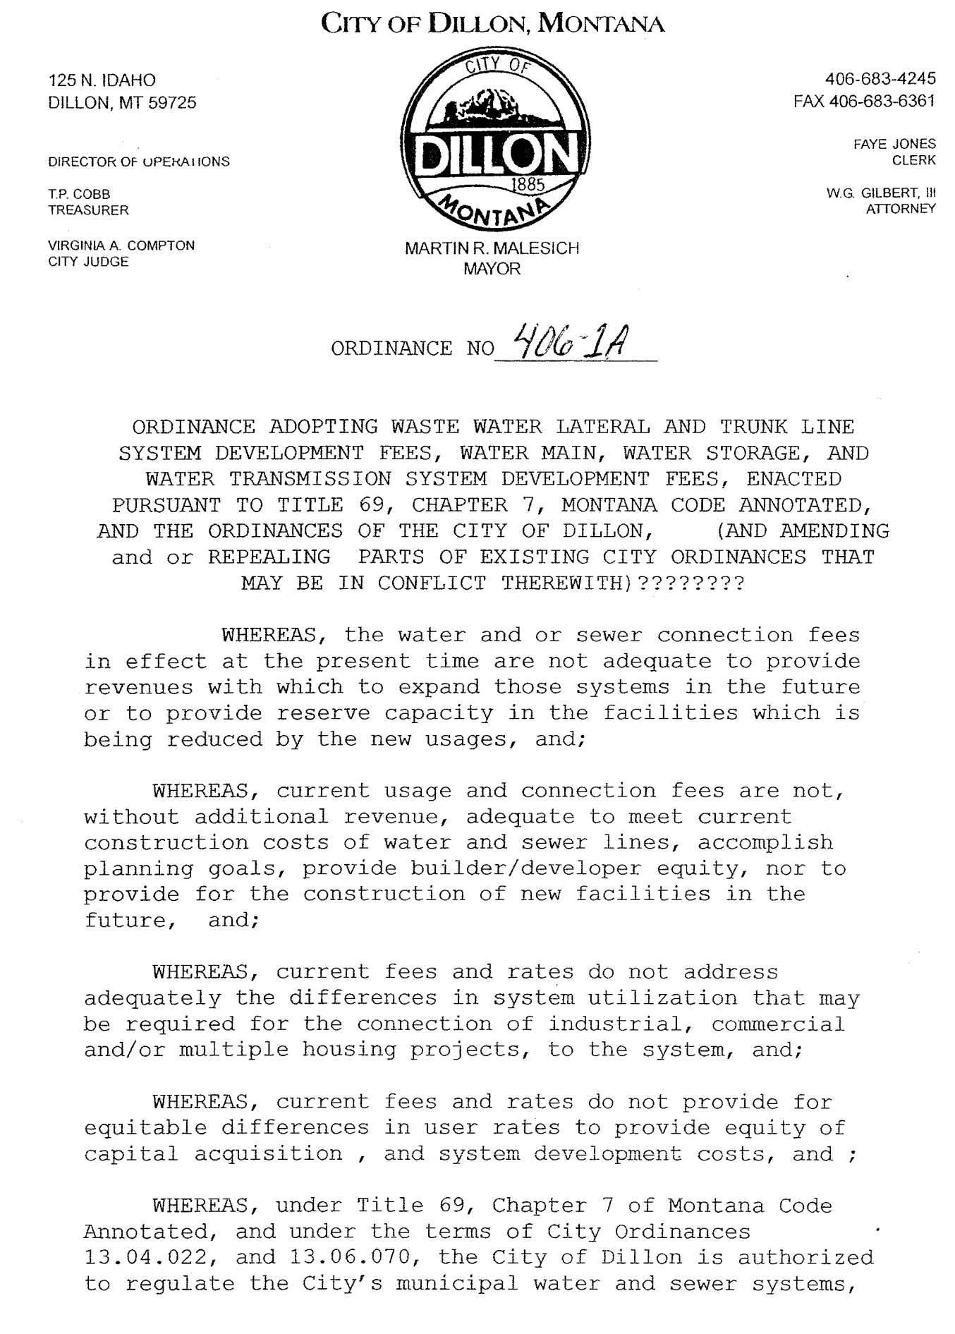
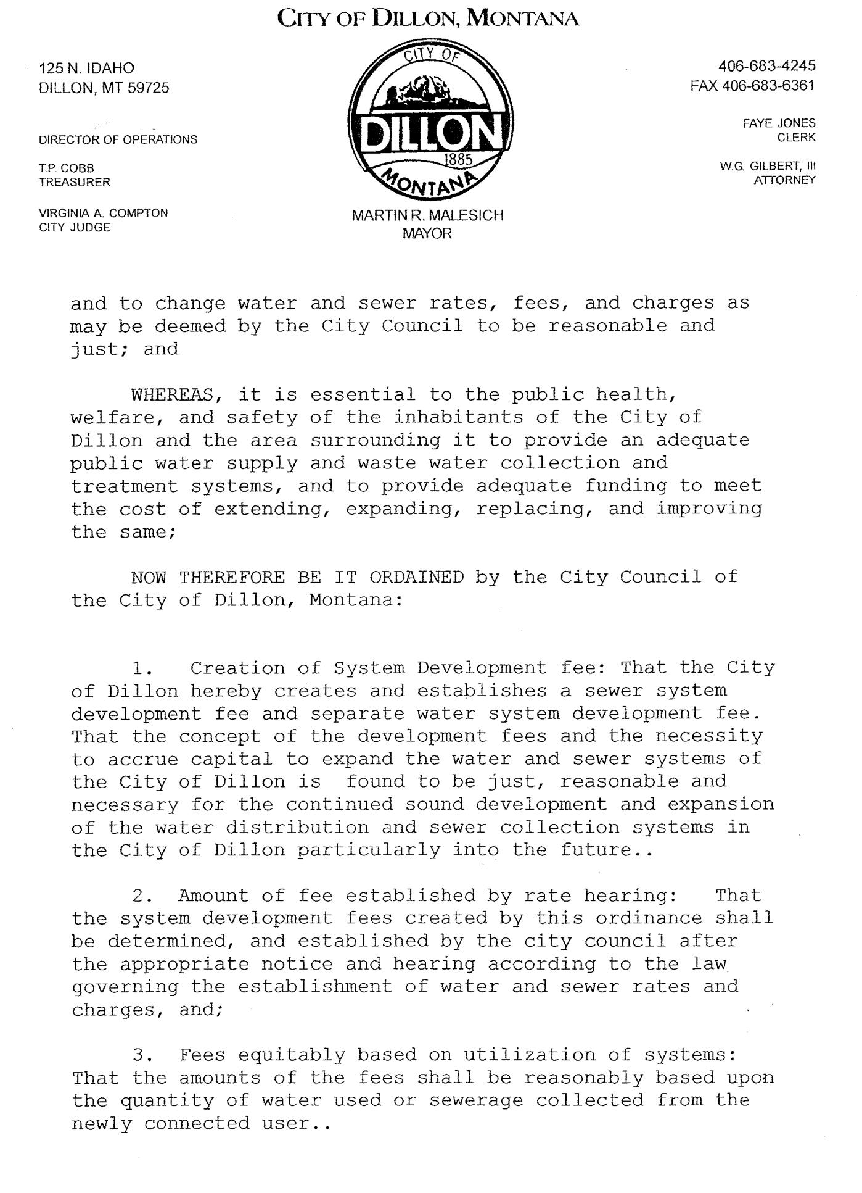
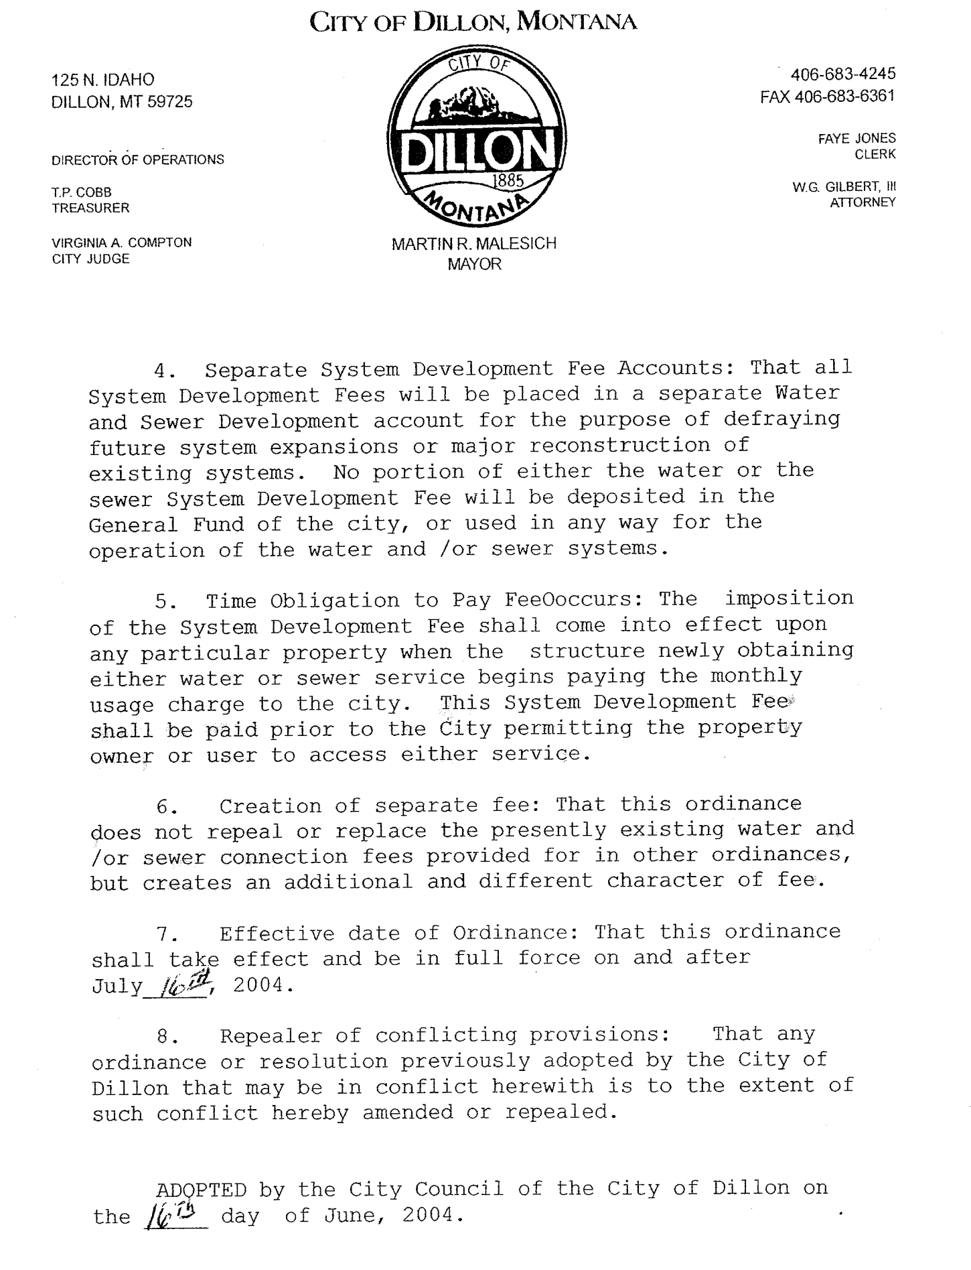
16-55-30 PRE-APPLICATION MEETING SUBDIVIDER RESPONSIBILITIES

At the time of the Pre-Application meeting request, the subdivider shall provide to the Subdivision Administrator a vicinity sketch of the proposed subdivision showing the layout of the proposed features in relation to existing site conditions. The sketch may be drawn directly on a print of a topographic map of the area proposed for division at a scale of 1 inch to 400 feet or larger that is adequate to show the property and must include the following: Information on the current status of the site, including:

- For both minor and major subdivisions if the developer has commenced any excavation or construction, all such activity shall cease.

A. Documentation on the Status of the Current Site

 Location;
 Approximate tract and lot boundaries of existing tracts of record;
 Description of general terrain;
 Natural features on the land, including water bodies, floodplains geologic hazards, and soil types;
 Existing structures and improvements;
 Existing utility lines and facilities serving the area to be subdivided;
 Existing easements and rights of way;
 Existing zoning or development regulation standards;
 Existing conservation easements;
 Existing covenants or deed restrictions;
 Water rights, including location of agricultural water facilities;
 Rights of first refusal for the property.

C. Proposed Subdivision Information

 Tract and proposed lot boundaries;
 Proposed public and private improvements;
 Location of utility lines and facilities;
 Easements and rights of way; and
 Parks and open space and proposed conservation easements.

B. Documentation of
Current Site
Information on the
Proposed Subdivision,
Including

 Tract and proposed lot boundaries;
 Ownership information such as deed, option to buy, or buy/sell agreement, including permission to subdivide, water rights;
 Proposed public and private improvements;
 Any special improvement districts and rights of first refusal for the property;
 Easements and rights of way; and;
 Parks and open space and proposed conservation easements.;
 Water rights including location of Agricultural Water Facilities;

16-55-45 SUBDIVISION APPLICATION SUBMITTAL

The subdivider shall submit to the Subdivision Administrator a subdivision application addressing the following topics and containing the materials, all described in more detail in the forms provided by the Subdivision Administrator, in the City of Dillon Subdivision Application Package.

- Abstract of Title (or
Title Report)

- Applicable Review Fee

- Appropriate Proposed Landscaping Design

- Completed And Signed Subdivision Application Form

- Compliance With City of Dillon Growth Policy

- Documentation of Existing Easements, Including Those For
Agricultural Water User Facilities

- Documentation of Legal And Physical Access

- Encroachment Permits From
Montana Department of Transportation or the Local Jurisdiction

- Engineering Plans For All Public And Private Improvements

- Environmental Assessment and/or Summary of Probable Impacts

- Existing Covenants And Deed
Restrictions

- Existing Mineral Rights

- Existing Water Rights

- Fire Risk Rating Analysis And Fire Prevention Plan
- FIRM or FEMA Panel Map

- Letter Identifying Floodplain Status

- Flood Hazard Evaluation

- Form of Subdivision Improvements Agreement, If Proposed
- Future Connectivity Opportunities with City of Dillon Capital Improvements Plan (CIP)

- Grading And Drainage Plan

- Hydrology Report for water resource impact (if applicable)

- Letter Identifying and Proposing Mitigation For Potential Hazards or Other Adverse Impacts as Identified In The Pre-Application Meeting and Not Covered By Any of The Other Required Materials

- Letter Indicating Locations of
Cultural or Historic Resources

- Letter Requesting A Revocation of Agricultural Covenant

- Lienholders’ Acknowledgement of Subdivision

- Names And Addresses of All Adjoining Property Owners
- Overall Development Plan If Development Is In Phases

- Parkland Dedication Calculations
- Petition For Annexation

- Petition For Zoning

- Preliminary Plat

- Proposed Disposition of Mineral Rights

- Proposed Disposition of Water Right
- Proposed Easements

- Proposed Road Plans And Profiles

- Re-Zoning Application or Approval

- Relevant And Reasonable Information as Identified by The Subdivision Administrator During The Pre-Application Meeting

- Topographic Map

- Traffic Study (If Applicable)

- Transportation Impact Analysis or Transportation Plan

- Variance Request or Approval

- Vicinity Sketch

- Water And Sanitation Information as Required

- Weed Management Plan and/or Re-Vegetation Plan

- Other Pertinent Information
Required to Satisfy the Elements of this Section.

CITY OF DILLON DOCUMENTS

Sources That May Require Review and Compliance

There are several ways to obtain the information.

City of Dillon

The City of Dillon Public copies at City Hall
The City of Dillon Public Library
The City of Dillon Web Page
Some may be purchased for a fee for a printed copy or a CD purchased.

Other documents may be purchased for a small copying fee.
Some may be available on the Internet.

- City of Dillon Municipal Codes
- City of Dillon Growth Policy
- City of Dillon Subdivision Regulations
- City of Dillon Zoning Regulations
- City of Dillon Capital Improvement Plan

Additional Sources

Beaverhead Chamber of Commerce
City or County Health Department
Floodplain Administrator

State

- Uniform Fire Codes
- IBC Residential Code
- Montana Codes Annotated
- Administrative Rules of Montana (ARM)

Federal

- Fair Housing
- American Disability Act

CITY OF DILLON

PROJECT NAME:

SUBDIVISION APPLICATION NO:

CHECKLIST OF ENTITIES THAT MUST BE CONTACTED AND WRITTEN RESPONSE RECEIVED OR IF NOT APPLICABLE. STATE WHY.

FEDERAL
- US Forest Service
- Bureau of Land Management
- US Fish Wildlife and Parks
- Bureau of Reclamation
- US Postal Service
- NRCS – Natural Resources Conservation Service

STATE
- Montana Department of Fish, Wildlife and Parks
- Montana Department of Transportation
- Montana Department of Environmental Quality
- Montana Department of Natural Resources and Conservation
- SHIPO – Montana State Historical Preservation Society

COUNTY
- Beaverhead County Sanitarian
- Beaverhead County Road Department
- Beaverhead County Fire Marshall
- Beaverhead County Sheriff
- Beaverhead County Solid Waste
- Beaverhead County Weed Board

CITY OF DILLON
- City of Dillon Police Department
- City of Dillon Water & Sewer Departments

OTHER ENTITIES
- NorthWestern Energy
- Vigilante Electric
- Applicable Phone Service Provider (Qwest)
- Applicable irrigation water district or ditch owners
- Adjacent Homeowners Associations
- Local School Districts (District #10 Elementary, Beaverhead County High School)
- Dillon Volunteer Fire Department
- Barrett Hospital & Healthcare, Beaverhead Ambulance

MONTANA DEPARTMENT OF ENVIRONMENTAL QUALITY/LOCAL
GOVERNMENT JOINT APPLICATION FORM

This joint application for local government does not include some local information that we have requested in the City of Dillon Subdivision Application. Therefore, a local application and this Joint Application must be completed.

Unfortunately it does request some of the same information as previously requested but we must present the document to you as completed by the Department of Environmental Quality.

We appreciate your cooperation in completing both applications.

Thank you,

Subdivision Administrator

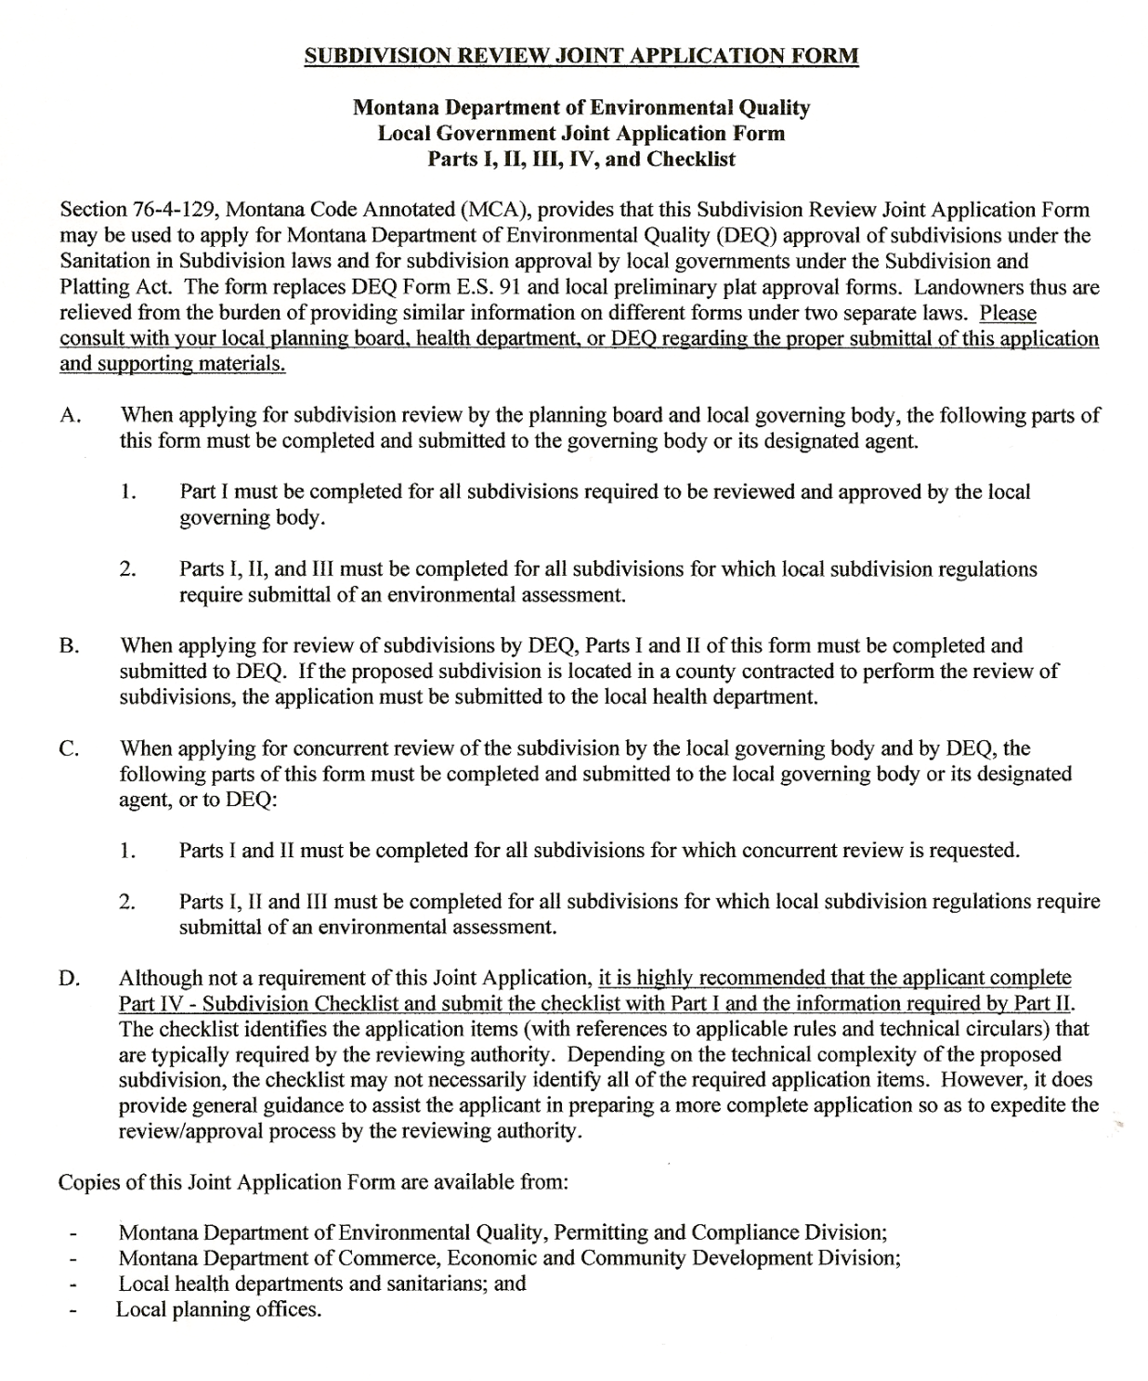
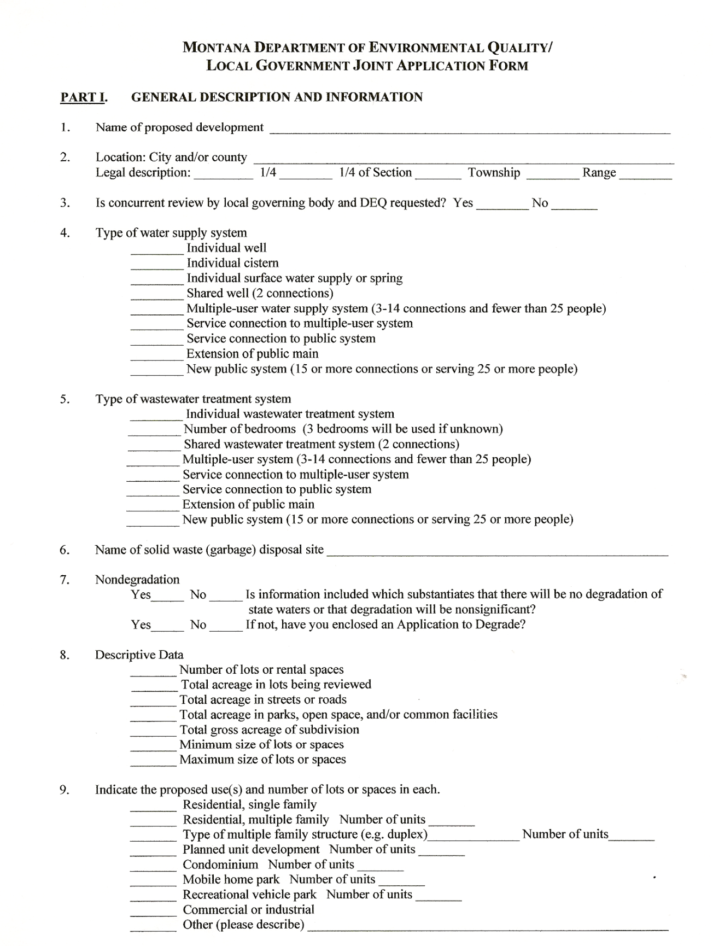
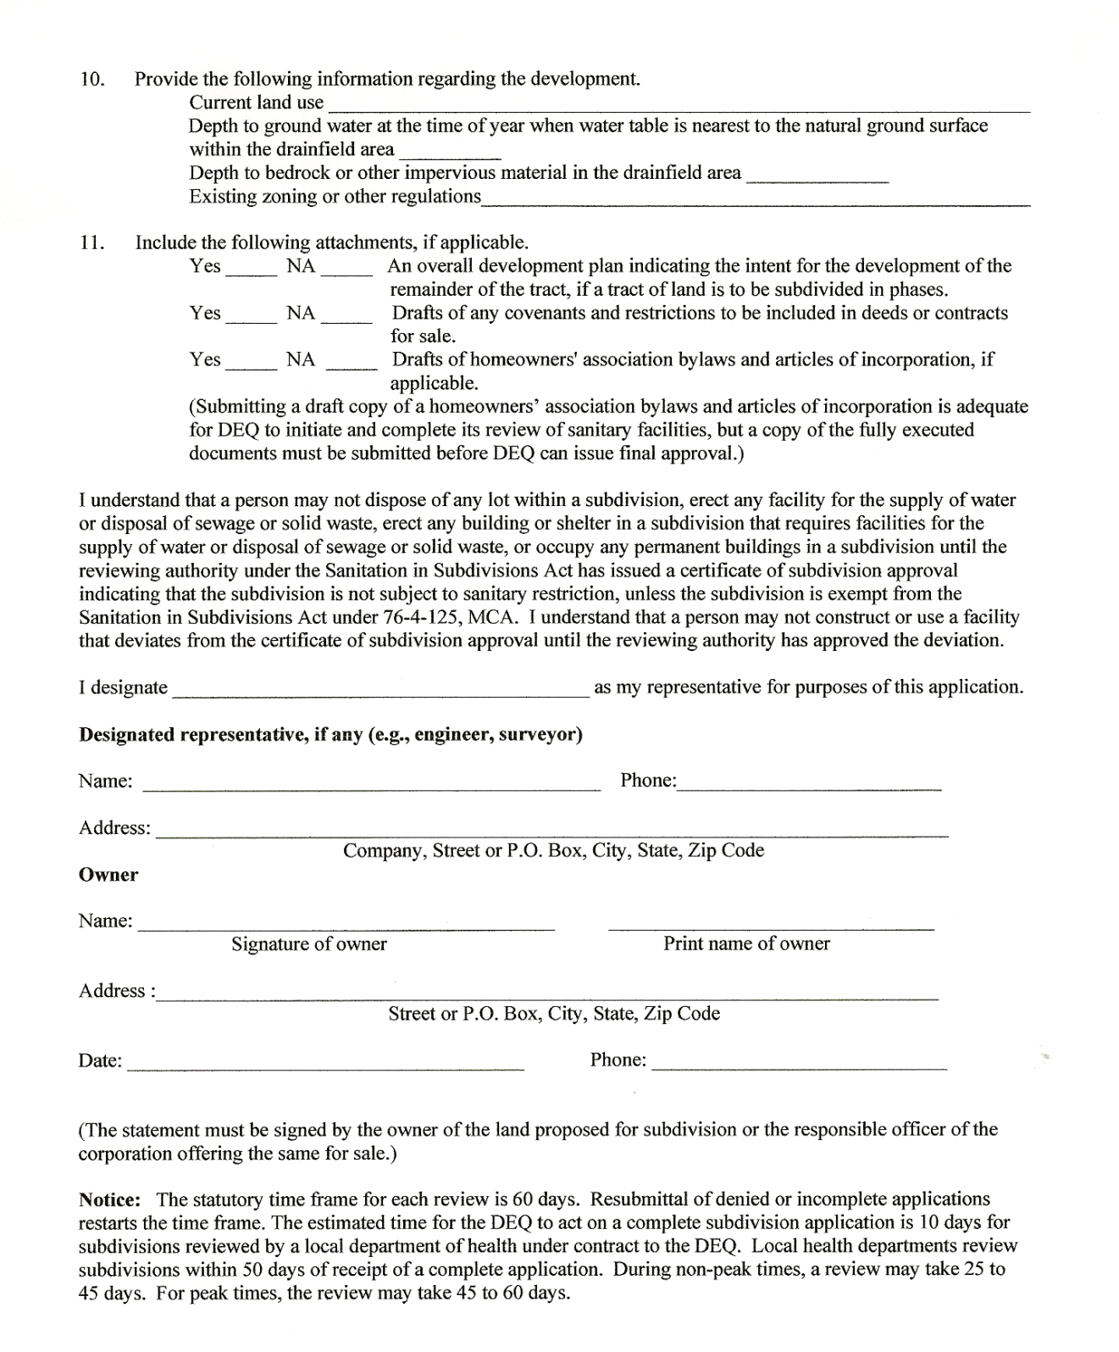
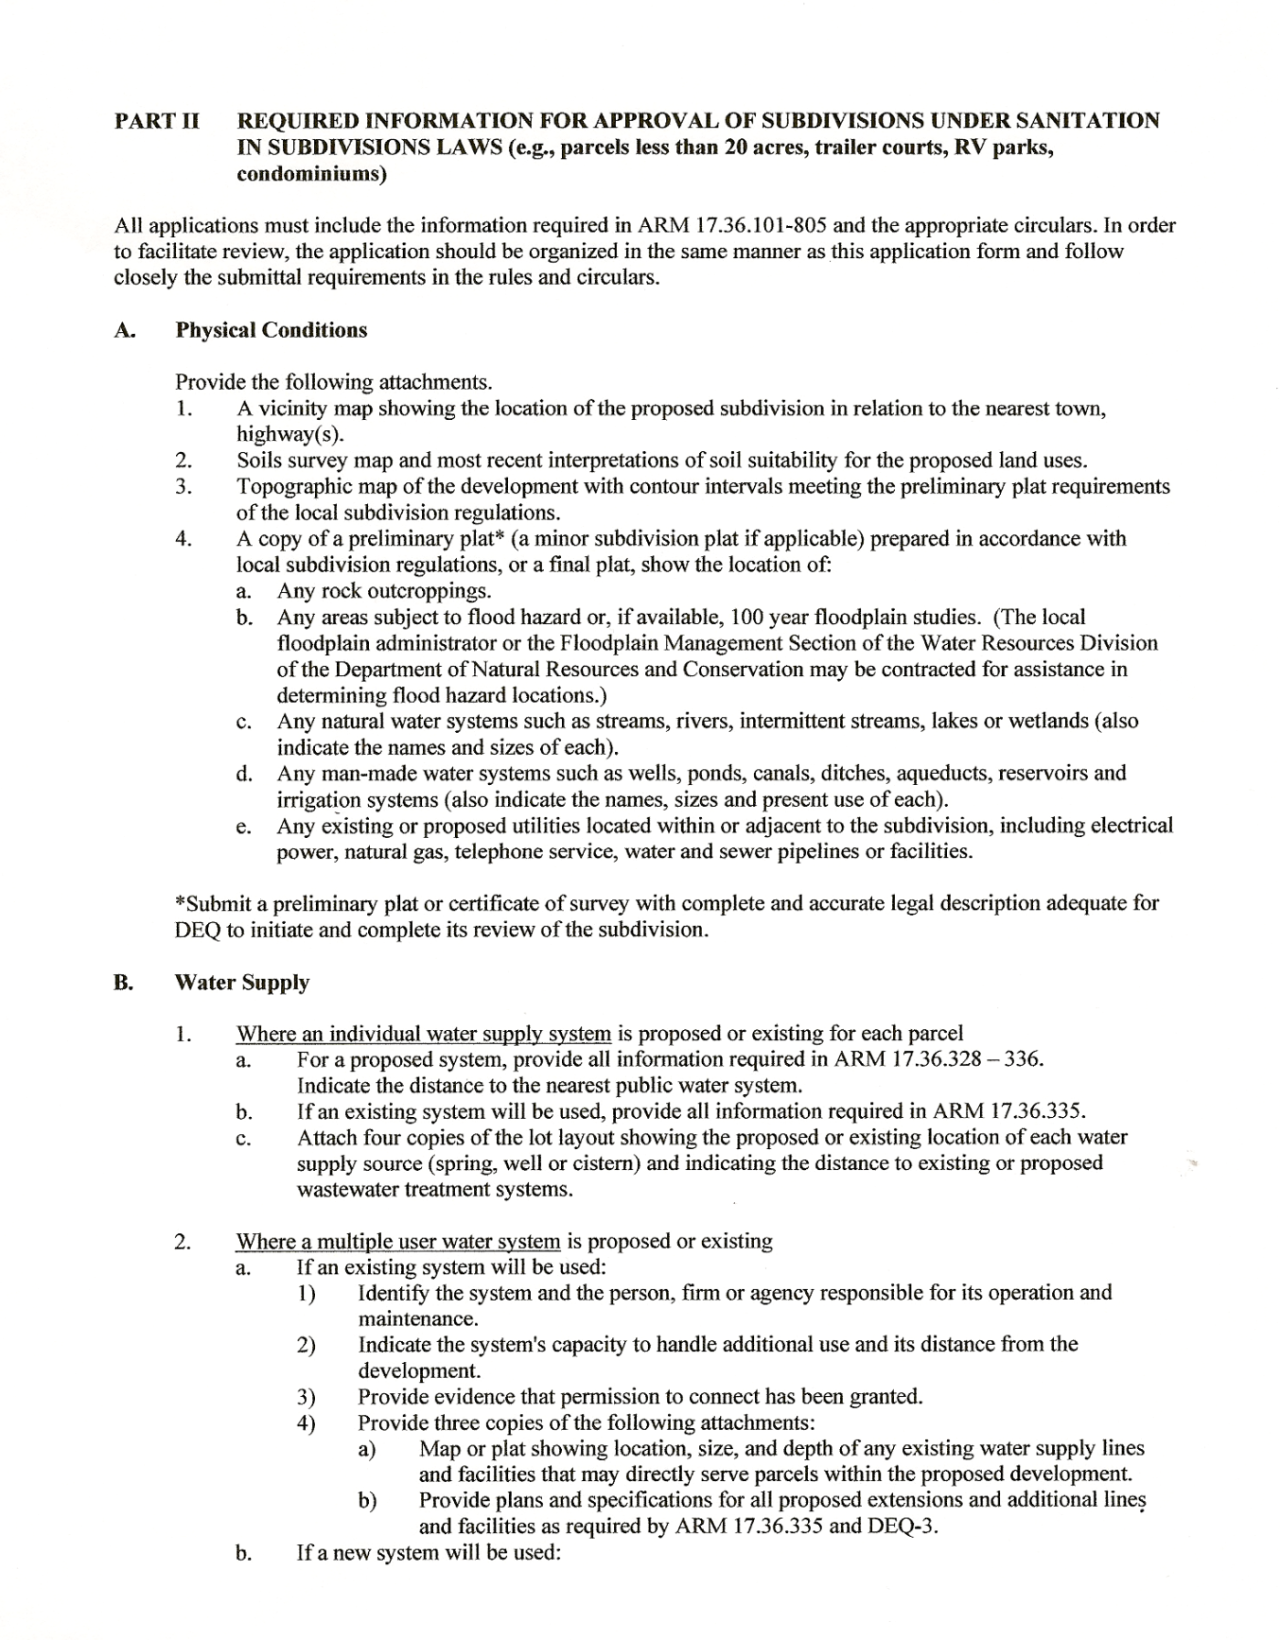
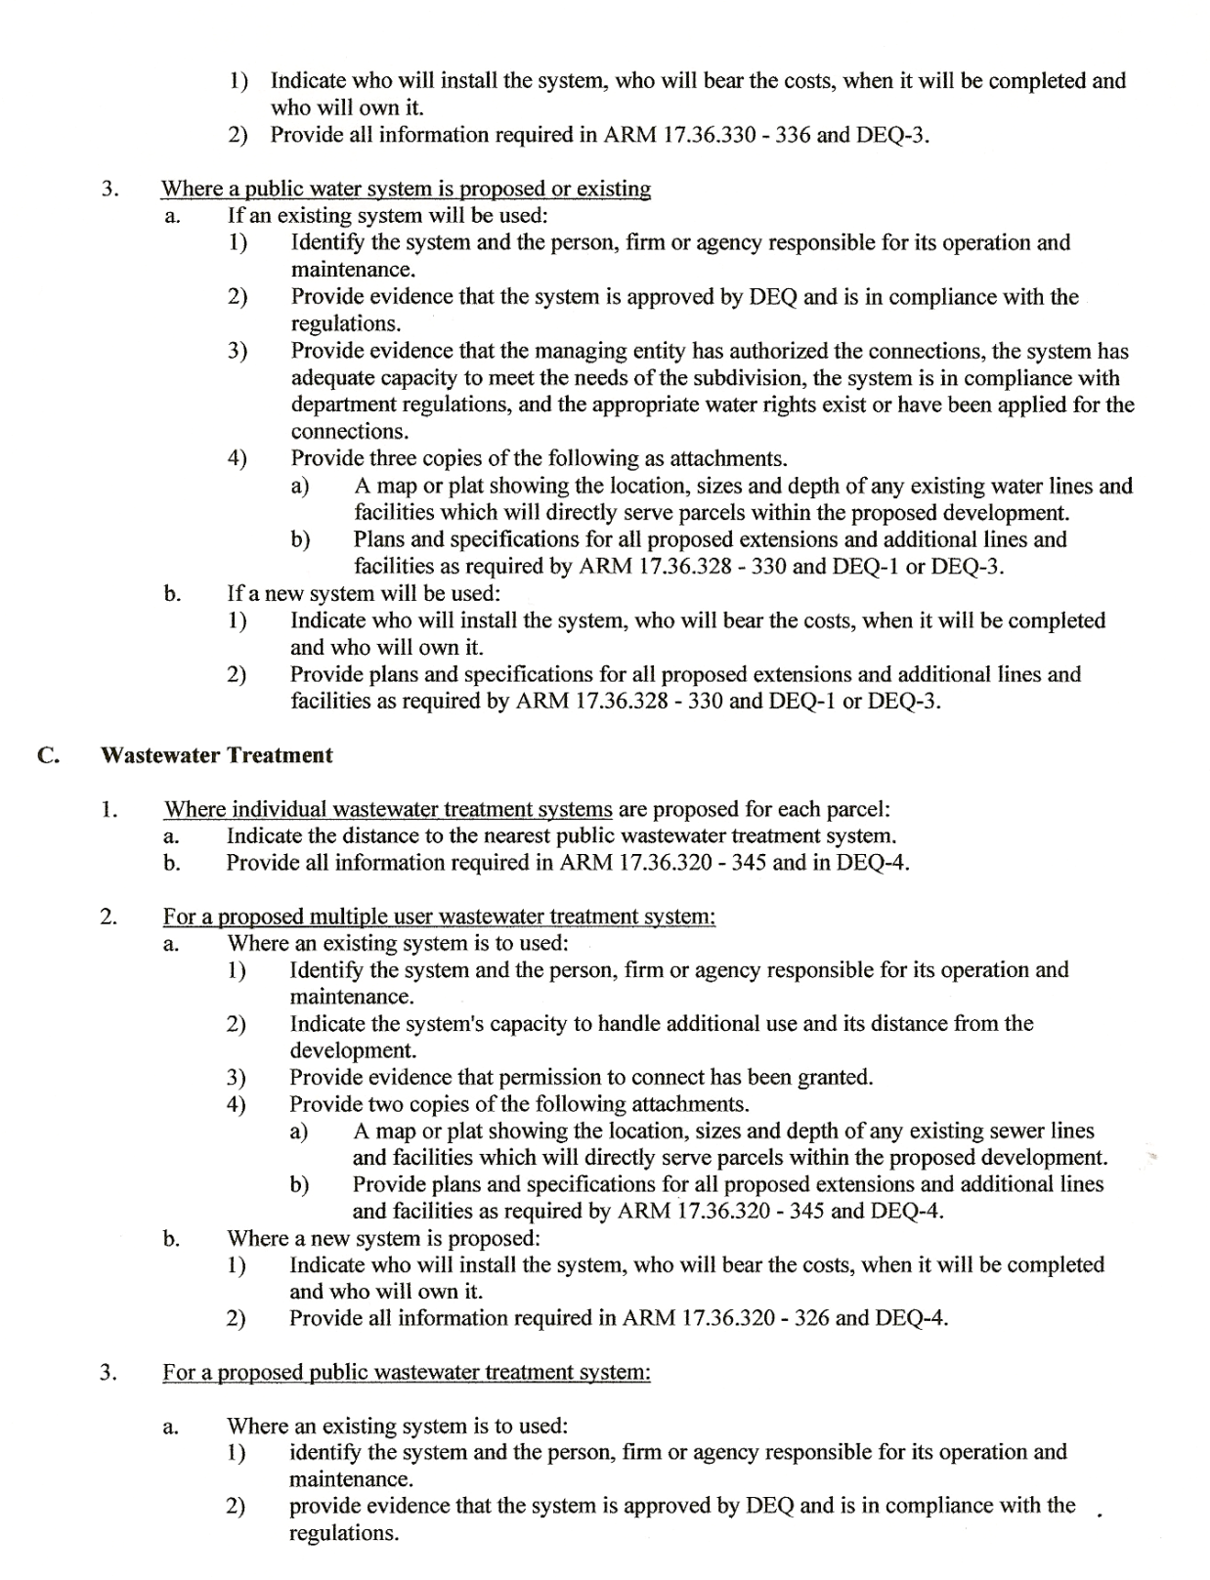
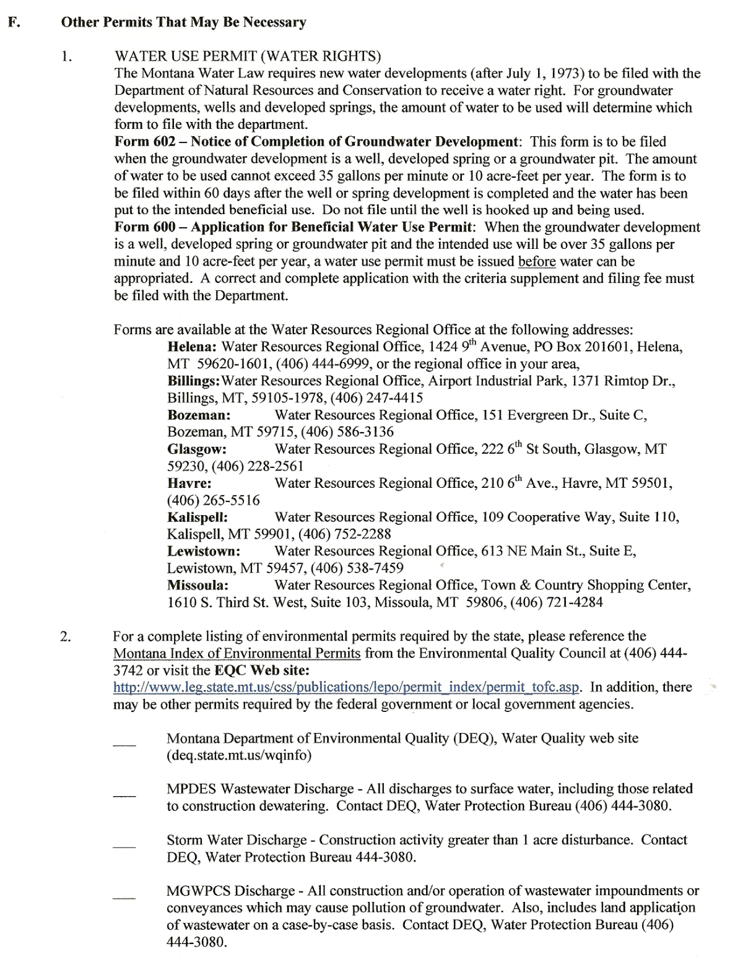
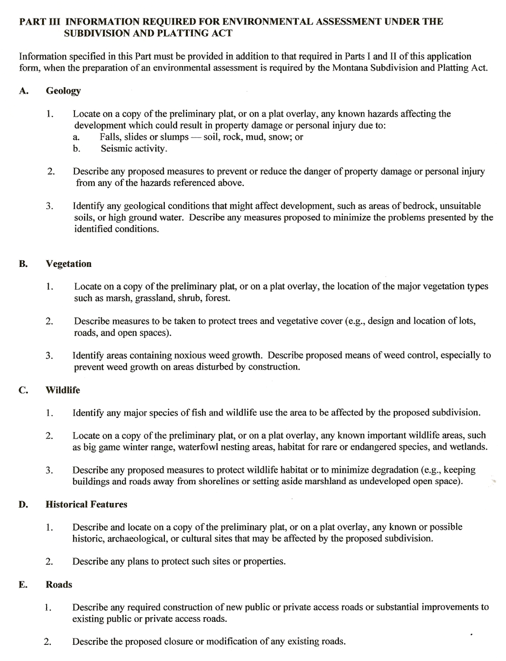
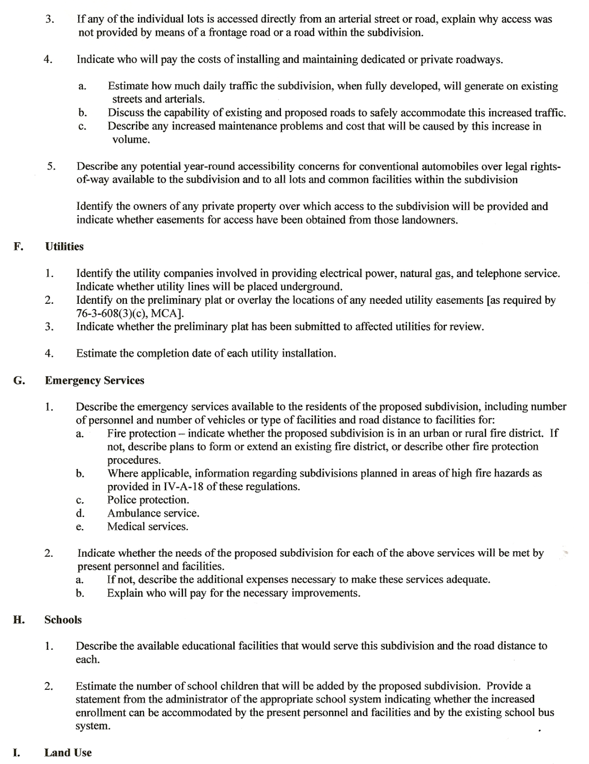
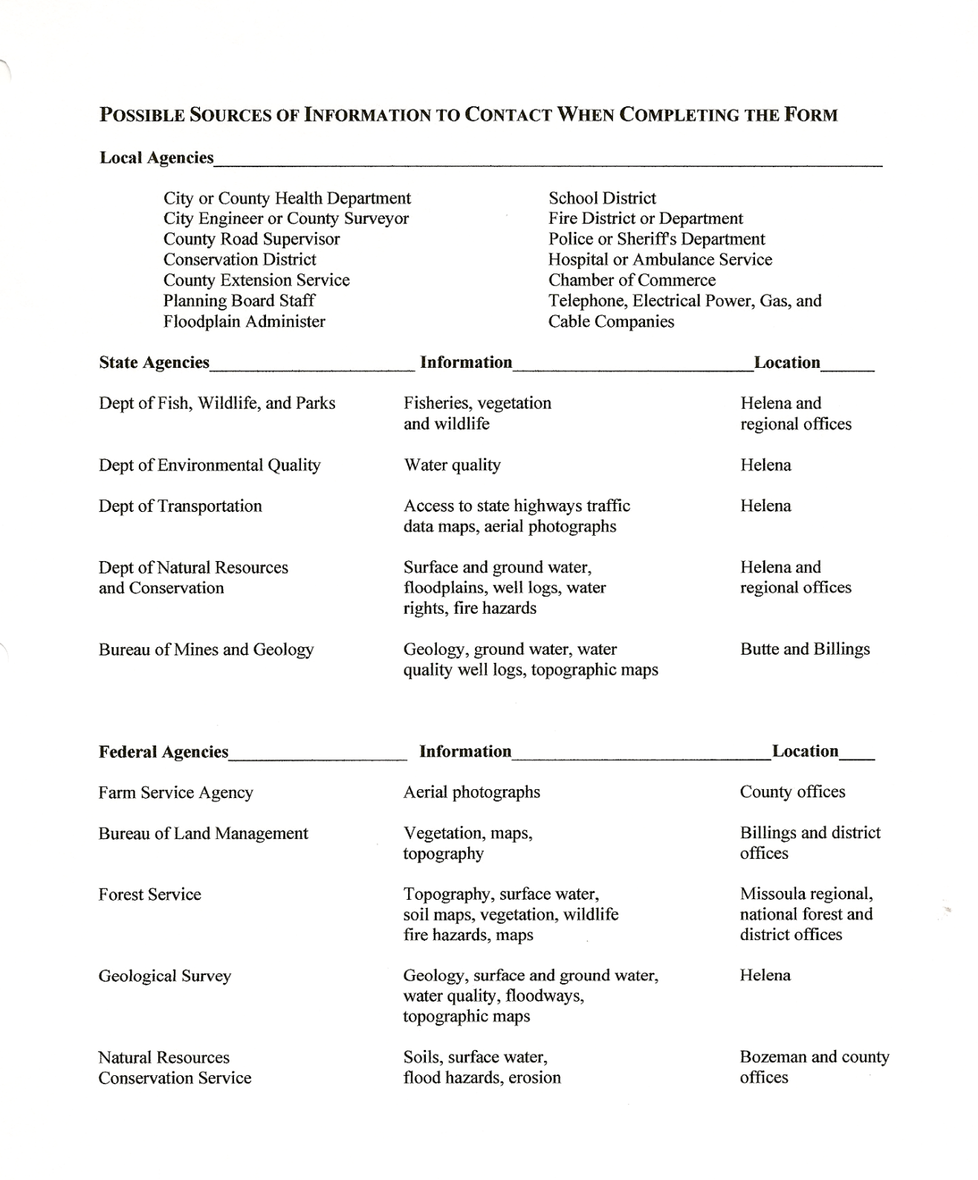

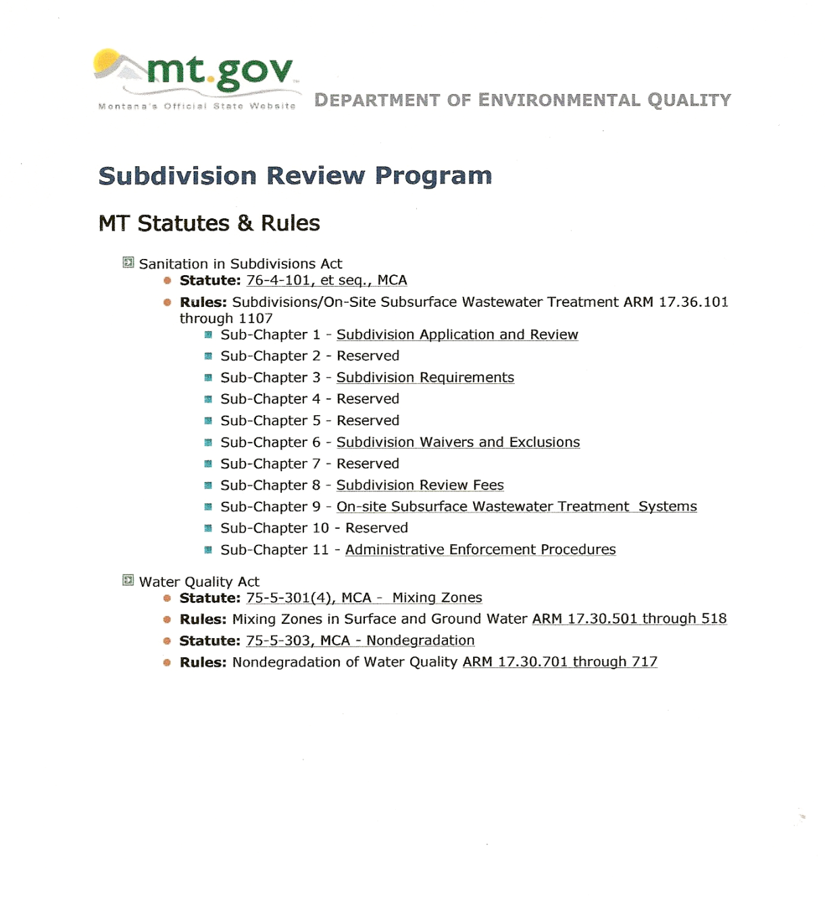

ANNEXATION FORMS FOR SUBDIVISION PROJECTS

Required if property outside incorporated boundaries of the City

- Application to Annex
- Questionnaire for Annexation
- Application for Zoning
- Zoning Questionnaire

CITY OF DILLON
Subdivision Application No.:

SUBDIVISION ANNEXATION APPLICATION AND QUESTIONNAIRE

PUBLIC HEARING(S) ARE REQUIRED AND COSTS OF PUBLICATION ARE PAID BY APPLICANT. PROPERTY OWNER(S) ARE REQUIRED TO ATTEND ALL MEETINGS AND HEARINGS.

Date:

PLEASE PRINT

Project Name:

Property Owner:

Contact Address:

Phone: Fax: e-mail:

Project Subdivider/Developer If Different Than Property owner:

Phone: Fax: e-mail:

Physical Address (if one exists):

Legal Description: Lot Block(s) Parcel(s)

Tract COS or Book

Deeds in Sec.: T R

Assessors Code Tax ID

Metes & Bounds Perimeter Legal Description

I (we), the undersigned, hereby certify that the information in this request is true and correct to the best of my (our) knowledge.

Date Signed: Signature Print Name
Property Owner

Date Signed: Signature Print Name
Subdivider/Developer

Notorized:
Office Use: Date Paid Amt:

CITY OF DILLON

SUBDIVISION ANNEXATION QUESTIONNAIRE

Project Name: Subdivision Application No.:

ANNEXATION QUESTIONNAIRE:

This questionnaire shall be completed and returned with annexation application Any item marked “NO” or “N/A” (not applicable) must be explained in a narrative attached to questionnaire. Incomplete submittals will be returned.

 | Yes | No | N/A
Is the property contiguous to the City of Dillon?

Is the property wholly surrounded by the City of Dillon?

Is the property currently contracting with the city for
municipal services such as water, sanitary and/or
fire protection. If so, which services are currently contracted?

Does the property lie within the service boundary of the
existing sewer system and/or water system depicted in the
City’s Capital Improvement Plan?

Type of Annexations

Title 7 Part 43 Montana Code Annotated
Annexation of contiguous land to the City of Dillon:

Title 7 Part 45 Montana Code Annotated
Annexation of Wholly Surrounded Land:

Title 7 Part 46 Montana Code Annotated
Annexation by Petition:

Title 7 Part 47 Montana Code Annotated
Annexation with the Provision of Services

Annexation Policies: | Yes | No | N/A
The property owner(s) shall dedicate needed easements and/or rights for collector and arterial streets?

The property owner(s) shall sign waivers of right to
protest the creation of future Special Improvements Districts
to provide essential services for the development of the City.

Will the property owner(s) transfer usable water rights to the City of Dillon?

If it is found that adequate services cannot be provided to ensure public health, safety and welfare, has the property owner(s) provided a written plan for the accommodation of these services? Attach plan if applicable.

Do unpaved county roads comprise the most commonly used route to gain access to the property?

Do current City streets comprise the primary access route to property?

Is the property currently in agricultural use?

Number of residential structures on property and are they currently occupied?

Number and type of commercial structures on property and type of use?

Are any structures rented, leased or occupied in any manner?

Estimate of existing population on property.

Existing on-site facilities and utilities (gas, power, telephone, cable, septic systems, wells, etc.). Attach map of locations.

Subdivider/Developer agrees zoning and annexation may be done at the same time.

I (we), the undersigned, hereby certify that the information in this request is true and correct to the best of my (our) knowledge.

Date Signed: Signature Print Name
Property Owner

Date Signed: Signature Print Name
Subdivider/Developer

STATE OF MONTANA )

COUNTY OF BEAVERHEAD )
On this day of , 20 , before me, the undersigned, a Notary Public for the State of Montana, personally appeared .
Known to me to be the persons whose name is subscribed to the within instrument and acknowledged to me that they executed the same
IN WITNESS WHEREOF, I have hereunto set my hand and affixed my Notarial
Seal this day of 20 .

Notary Public for the State of Montana
Residing at , Montana
My commission expires

CERTIFICATE OF ADJOINING PROPERTY OWNERS LIST

I, , hereby certify that, to the best of my knowledge, the attached name and address list of all adjoining property owners (including all individual condominium owners) within 200 feet of the property located at , is a true and accurate list from the last declared Beaverhead County tax records. I further understand that an inaccurate list may delay review of the project.

Date Signed: Signature:
Property Owner/Subdivider/Developer (if different)
or designated representative
Print Name:

CONTACT WITH ADJACENT PROPERTY OWNERS IS ENCOURAGED AND WRITTEN DOCUMENTS THAT THEY ARE IN AGREEMENT WITH REQUESTED ANNEXATION MAY BE ATTACHED.
STATE OF MONTANA )

COUNTY OF BEAVERHEAD )
On this day of , 20 , before me, the undersigned, a Notary Public for the State of Montana, personally appeared .
Known to me to be the persons whose name is subscribed to the within instrument and acknowledged to me that they executed the same
IN WITNESS WHEREOF, I have hereunto set my hand and affixed my Notarial
Seal this day of 20 .

Notary Public for the State of Montana
Residing at , Montana
My commission expires

CITY OF DILLON
APPLICATION NO.:
APPLICATION AND QUESTIONNAIRE FOR ZONING OF SUBDIVISION

PUBLIC HEARING(S) ARE REQUIRED COSTS OF PUBLICATION ARE PAID BY APPLICANT. PROPERTY OWNER(S) SHALL ATTEND ALL MEETINGS AND HEARINGS.

PLEASE PRINT

Project Name:

Property Owner: Phone: Fax:

Subdivider/Developer (if different): Phone: Fax:

E-Mail:

Legal Description: Lot Block(s) Parcel(s)

Tract COS Book

Deeds in Sec. T R

Assessors Code Tax ID

Metes & Bounds Perimeter Legal Description:

Current Zone or Zones Requested:

Reason for Requested Zone or Zones:

SHOW ON A PLAT THE ZONE REQUESTED AND HAVE ALL ZONES CLEARLY DEFINED ON PLAT IF MORE THAN ONE ZONE BEING REQUESTED.

SHOW ON THE PLAT THE ADJACENT PROPERTY ZONING AND STATE WHY REQUESTED ZONING IS APPROPRIATE TO ADJACENT DISTRICTS:

I (we), the undersigned, hereby certify that the information in this request is true and correct to the best of my (our) knowledge.

Date Signed: Signature Print Name
Property Owner

Date Signed: Signature Print Name
Subdivider/Developer

STATE OF MONTANA )

COUNTY OF BEAVERHEAD )
On this day of , 20 , before me, the undersigned, a Notary Public for the State of Montana, personally appeared .
Known to me to be the persons whose name is subscribed to the within instrument and acknowledged to me that they executed the same
IN WITNESS WHEREOF, I have hereunto set my hand and affixed my Notarial
Seal this day of 20 .

Notary Public for the State of Montana
Residing at , Montana
My commission expires

CERTIFICATE OF ADJOINING PROPERTY OWNERS LIST

I, , hereby certify that, to the best of my knowledge, the attached name and address list of all adjoining property owners (including all individual condominium owners) within 200 feet of the property located at , is a true and accurate list from the last declared Beaverhead County tax records. I further understand that an inaccurate list may delay review of the project.

Date Signed: Signature:
Property Owner/Subdivider/Developer (if different)
or designated representative
Print Name:

STATE OF MONTANA )

COUNTY OF BEAVERHEAD )
On this day of , 20 , before me, the undersigned, a Notary Public for the State of Montana, personally appeared .
Known to me to be the persons whose name is subscribed to the within instrument and acknowledged to me that they executed the same
IN WITNESS WHEREOF, I have hereunto set my hand and affixed my Notarial
Seal this day of 20 .

Notary Public for the State of Montana
Residing at , Montana
My commission expires

CONTACT WITH ADJACENT PROPERTY OWNERS IS ENCOURAGED AND WRITTEN DOCUMENTS THAT THEY ARE IN AGREEMENT WITH REQUESTED ANNEXATION MAY BE ATTACHED.
CITY OF DILLON
APPLICATION NO.:
ZONING QUESTIONNAIRE IS TO BE ATTACHED TO APPLICATION FORM FOR ZONING OF UNZONED PROPERTY.

The questionnaire shall be completed and returned with zoning request. Any item marked “NO” or “N/A” (not applicable) must be explained in a narrative attached to questionnaire. Incomplete submittals will be returned.

Project Name:

Property Owner:

Subdivider/Developer (if different):

Mark All

Zoning Provision Criteria: | Yes | No | N/A
- Is the zoning designed in accordance with the Growth Policy?
- Is the zoning designed to lessen congestion in the streets?
3. Will the new zoning promote health, welfare and public safety?

- Will the zoning secure safety from fire, panic and other dangers?

- Will the zoning provide adequate light and air?

6. Will the zoning prevent the overcrowding of land?

- Will the zoning avoid the undue concentration of population?

- Will the zoning facilitate the adequate provision of transportation, water, sewer, schools, parks, fire, police, and other public requirements?

9. Does the zoning give consideration to the peculiar
suitability of the property for particular uses?

10. Does the zoning give reasonable consideration to the character of the district?

- Was the zoning adopted with a view to conserving the value of buildings?

- Will the zoning encourage the most appropriate use of land throughout the district?

13. Will the requested zoning provide for the orderly development of the jurisdictional area?

14. Will the requested zoning provide for the coordination of roads within subdivided land with other roads, both existing and planned?

15. Will the requested zoning provide for the dedication of land for roadways and for public utility easements?

16. Will the requested zoning provide for the improvement of roads?

17. Will the requested zoning provide for adequate open spaces for travel, light, air and recreation?

18. Will the requested zoning provide for adequate transportation, water, and drainage?

19. Will the requested zoning provide for the regulation of sanitary facilities?

20. Will the requested zoning provide for the avoidance of a subdivision which would involve unnecessary environmental degradation and the avoidance of danger of injury to health, safety, or welfare by reason of natural hazard or the lack of water, drainage, access, transportation, or other public services or would necessitate an excessive expenditure of public funds for the supply of such service?

I (we), the undersigned, hereby certify that the information in this request is true and correct to the best of my (our) knowledge.

Date Signed: Signature Print Name
Property Owner

Date Signed: Signature Print Name
Subdivider/Developer

STATE OF MONTANA )

COUNTY OF BEAVERHEAD )
On this day of , 20 , before me, the undersigned, a Notary Public for the State of Montana, personally appeared .
Known to me to be the persons whose name is subscribed to the within instrument and acknowledged to me that they executed the same
IN WITNESS WHEREOF, I have hereunto set my hand and affixed my Notarial
Seal this day of 20 .

Notary Public for the State of Montana
Residing at , Montana
My commission expires

CERTIFICATE OF ADJOINING PROPERTY OWNERS LIST

I, , hereby certify that, to the best of my knowledge, the attached name and address list of all adjoining property owners (including all individual condominium owners) within 200 feet of the property located at , is a true and accurate list from the last declared Beaverhead County tax records. I further understand that an inaccurate list may delay review of the project.

Date Signed: Signature:
Property Owner/Subdivider/Developer (if different)
or designated representative
Print Name:

STATE OF MONTANA )

COUNTY OF BEAVERHEAD )
On this day of , 20 , before me, the undersigned, a Notary Public for the State of Montana, personally appeared .
Known to me to be the persons whose name is subscribed to the within instrument and acknowledged to me that they executed the same
IN WITNESS WHEREOF, I have hereunto set my hand and affixed my Notarial
Seal this day of 20 .

Notary Public for the State of Montana
Residing at , Montana
My commission expires

CONTACT WITH ADJACENT PROPERTY OWNERS IS ENCOURAGED AND WRITTEN DOCUMENTS THAT THEY ARE IN AGREEMENT WITH REQUESTED ZONING MAY BE ATTACHED.
FORMS FOR PROPERTY ALREADY ZONED

- Application to change, amend or modify zone

- Zoning Questionnaire

CITY OF DILLON
PETITION AND QUESTIONAIRE TO CHANGE, AMEND, MODIFY, SUPPLEMENT OR REPEAL REGULATIONS OR DISTRICT BOUNDARIES OR REZONE OF DISTRICT PURSUANT TO TITLE 17 CHAPTER 17-88 AMENDMENTS.

PUBLIC HEARING(S) ARE REQUIRED AND COSTS OF PUBLICATION ARE PAID BY APPLICANT. PROPERTY OWNER(S) SHALL ATTEND ALL MEETINGS AND HEARINGS.

Please Print
Petitioner: Date:
Address:
Phone: Fax: E-Mail:
Technical/Professional Assistance(if applicable):
Name:
Address:
Phone: Fax: E-Mail:
Do you own or are you purchasing in the District: Own: Purchasing:
Physical Address:
Legal Description: Lot(s) Block(s) Parcel(s)
Tract(s) COS Book
Deeds in Sec. T R Assessor Code
Metes and Bounds Perimeter (attached):
Reason for Application:

Petition to Change: Identify Title 17 Zoning Regulations Chapter, Section, and Ordinance Number Petitioner is requesting changed:

Requested Change:

Boundary Change: Identify on Map Current District Boundary and show Boundary requested:
Rezone Entire District: Current Zone: Requested Zone:
Show on Map adjacent districts and state why request is appropriate to adjacent District(s):
I, the undersigned hereby certify that the information contained in the Application is true and correct to the best of my knowledge.

Date Signed: Signature of Purchaser
Print Name
Notary

Date Signed: Signature of Current Owner
Print Name

STATE OF MONTANA )

COUNTY OF BEAVERHEAD )
On this day of , 20 , before me, the undersigned, a Notary Public for the State of Montana, personally appeared .
Known to me to be the persons whose name is subscribed to the within instrument and acknowledged to me that they executed the same
IN WITNESS WHEREOF, I have hereunto set my hand and affixed my Notarial
Seal this day of 20 .

Notary Public for the State of Montana
Residing at , Montana
My commission expires

Office Use:
Date Fee Pd: Amt: Zoning Comm. Hearing: Published:
Council Hearing: Published: Review 76-2-305 MCA for Protest Procedures

CERTIFICATE OF ADJOINING PROPERTY OWNERS LIST

I, , hereby certify that, to the best of my knowledge, the attached name and address list of all adjoining property owners (including all individual condominium owners) within 200 feet of the property located at , is a true and accurate list from the last declared Beaverhead County tax records. I further understand that an inaccurate list may delay review of the project.

Date Signed: Signature:
Property Owner/Subdivider/Developer (if different)
or designated representative
Print Name:

STATE OF MONTANA )

COUNTY OF BEAVERHEAD )
On this day of , 20 , before me, the undersigned, a Notary Public for the State of Montana, personally appeared .
Known to me to be the persons whose name is subscribed to the within instrument and acknowledged to me that they executed the same
IN WITNESS WHEREOF, I have hereunto set my hand and affixed my Notarial
Seal this day of 20 .

Notary Public for the State of Montana
Residing at , Montana
My commission expires

CONTACT WITH ADJACENT PROPERTY OWNERS IS ENCOURAGED AND WRITTEN DOCUMENTS THAT THEY ARE IN AGREEMENT WITH REQUESTED ANNEXATION MAY BE ATTACHED.

CITY OF DILLON
APPLICATION NO.:
THE ZONING QUESTIONNAIRE IS TO BE ATTACHED TO THE PETITION FORM TO CHANGE, AMEND, MODIFY, SUPPLEMENT OR REPEAL REGULATIONS OR DISTRICT BOUNDARIES OR REZONE OF DISTRICT PURSUANT TO TITLE 17 CHAPTER 17-88 AMENDMENTS.

Project Name:

Property Owner:

Subdivider/Developer (if different):

The questionnaire shall be completed and returned with zoning request. Any item marked “NO” or “N/A” (not applicable) must be explained in a narrative attached to questionnaire. Incomplete submittals will be returned.

Mark All

Zoning Provision Criteria: | Yes | No | N/A
- Is the zoning designed in accordance with the Growth Policy?

- Is the zoning designed to lessen congestion in the streets?

- Will the zoning promote health and general welfare?

- Will the zoning secure safety from fire, panic and other dangers?

- Will the zoning provide adequate light and air?

- Will the zoning prevent the overcrowding of land?

- Will the zoning avoid the undue concentration of population?

- Will the zoning facilitate the adequate provision of
transportation, water, sewer, schools, parks, fire, police, and other public requirements?

- Does the zoning give consideration to the peculiar suitability of the property for particular uses?

 |  | Yes | No | N/A
- Does the zoning give reasonable consideration to the character of the district?

 | - Was the zoning adopted with a view to conserving the value of buildings?
 | - Will the zoning encourage the most appropriate use of land throughout the Subdivision if a request to change, amend, or modify current zoning?
 | - Will the requested zoning provide for the orderly development of the jurisdictional area?
 | - Will the requested zoning provide for the coordination of roads within subdivided land with other roads, both existing and planned?
 | - Will the requested zoning provide for the dedication of land for roadways and for public utility easements?
 | - Will the requested zoning provide for the improvement of roads?
 | - Will the requested zoning provide for adequate open spacesfor travel, light, air and recreation?
 | - Will the requested zoning provide for adequate transportation, water, and drainage?
 | - Will the requested zoning provide for the regulation of sanitary facilities?
 | - Is the change significantly different from prevailing use in the area?
 | - Would the change of use petition be small, although not solely in physical size? Are there other property owners in the district that will benefit from the change?
 | - Is the change more in the nature of special legislation designed to benefit one or a few property owners in the district at the expense of the surrounding property owners or general public?
 | - Will the change request have any effect on the streets and roads both existing and planned?

 | Yes | No | N/A
- Will the requested zoning provide for the avoidance of subdivision which would involve unnecessary environmental degradation and the avoidance of danger of injury to health, safety, or welfare by reason of natural hazard or the lack of water, drainage, access, transportation, or other public services or would necessitate an excessive expenditure of public funds for the supply of such service?

Attach a list of adjacent property owners within 200 ft. of the application. Contact with the adjacent property owners and residents is encouraged and written signed documents that they agree with the request can be attached.

I, the undersigned hereby certify that the information contained in the Application is true and correct to the best of my knowledge.

Date Signed: Signature of Purchaser
Print Name

Date Signed: Signature of Current Owner
Print Name

STATE OF MONTANA )

COUNTY OF BEAVERHEAD )
On this day of , 20 , before me, the undersigned, a Notary Public for the State of Montana, personally appeared .
Known to me to be the persons whose name is subscribed to the within instrument and acknowledged to me that they executed the same
IN WITNESS WHEREOF, I have hereunto set my hand and affixed my Notarial
Seal this day of 20 .

Notary Public for the State of Montana
Residing at , Montana
My commission expires
CERTIFICATE OF ADJOINING PROPERTY OWNERS LIST

I, , hereby certify that, to the best of my knowledge, the attached name and address list of all adjoining property owners (including all individual condominium owners) within 200 feet of the property located at , is a true and accurate list from the last declared Beaverhead County tax records. I further understand that an inaccurate list may delay review of the project.

Date Signed: Signature:
Property Owner/Subdivider/Developer (if different)
or designated representative
Print Name:

STATE OF MONTANA )

COUNTY OF BEAVERHEAD )
On this day of , 20 , before me, the undersigned, a Notary Public for the State of Montana, personally appeared .
Known to me to be the persons whose name is subscribed to the within instrument and acknowledged to me that they executed the same
IN WITNESS WHEREOF, I have hereunto set my hand and affixed my Notarial
Seal this day of 20 .

Notary Public for the State of Montana
Residing at , Montana
My commission expires

CONTACT WITH ADJACENT PROPERTY OWNERS IS ENCOURAGED AND WRITTEN DOCUMENTS THAT THEY ARE IN AGREEMENT WITH REQUESTED ANNEXATION MAY BE ATTACHED.

Beaverhead County Subdivision Noxious Weed Policy

1. A Beaverhead County Weed Management Plan approved by the Beaverhead County Weed Board will be filed with the Weed Board prior to final subdivision approval. This plan will include:
A. The name and address of the property owner or applicant.
B. The legal description and location of the property.
C. A vicinity or other map locating the property and ownership.
D. Noxious weed data:
1. Types of noxious weeds present on property.
2. Approximate number of acres infested with noxious weeds.
3. State the anticipated land use and other environmental concerns.
4. Provide weed control activities planned for control of noxious weeds.
5. Provide plans for future weed control for a period of 3 to 5 years.
6. Signature(s) of property owner(s) must appear on application and must be
notarized.

2. The Beaverhead County Weed Board, or its representative, will inspect the proposed subdivision with consideration given to the filed Weed Management Plan as a reference for noxious weeds infesting the subdivision acreage.

3. A fee will be paid by the developer to defray the expenses of the onsite inspection of the proposed subdivision and the review of the Subdivision Weed Management Plan. All fees will be paid to Beaverhead County Weed Control and are as follows:
A. Minor Subdivisions
1. A 1 lot minor subdivision will not be charged an inspection fee except for mileage
over 20 miles. (state mileage rate)
2. Subdivisions containing 2 to 3 lots will be charged an inspection fee of $25.00 plus
mileage over 20 miles. (state mileage rate)
3. Subdivisions containing 4 to 5 lots will be charged an inspection fee of $50.00 plus
mileage over 20 miles. (state mileage rate)
B. Major Subdivisions
1. Major subdivisions consisting of 6 or more lots will be charged an inspection fee of
$50.00 plus $10.00 per lot and mileage. (state mileage rate)
C. Subdivision Weed Management Plan Review and Approval Applications will not be
accepted unless accompanied by applicable fees.

4. After reviewing the Weed Management Plan and making an onsite inspection of the subdivision site, the Beaverhead County Weed Board will approved or reject the application.

Beaverhead County Weed District
2 South Pacific
Dillon, Montana 59725
Office 406-683-3790

Beaverhead County

Three Year Weed Management Plan

Plan # _________
Date ___________

Ownership and Location:
Name _________________________________________________________________
Address _______________________________________________________________
Phone _________________________________________________________________

Legal Description ______ ¼ ______ ¼ ______ ¼
Section ______ Township ______ Range ______

A Map identifying or locating the ownership must be included

Each Year planned will commit you to acres to control, how the control will be done, whom control will be done by and what weeds will be controlled.

Please list weeds on property and number of acres affected

Kinds of weed species on property: | Acres infested:

Year one (1) plan:
For year of ______________
Work will be done by _______________________________ Phone _________________
Time(s) of year control will be implemented: Spring ____ Summer ____ Fall ____ Other _____
Please explain if other:

Control method that will be used:

Herbicide control

Herbicide name | Weed specie | Rate per acre | Acres to be controlled

Cultural/Mechanical Control

Method of cultural/mechanical control | Weed specie | Acres to be controlled

Year two(2) plan:
For year of ______________
Work will be done by _______________________________ Phone _________________
Time(s) of year control will be implemented: Spring ____ Summer ____ Fall ____ Other ____
Please explain if other:

Control methods that will be used:

Herbicide control

Herbicide name | Weed specie | Rate per acre | Acres to be controlled

Cultural/Mechanical Control

Method of cultural/mechanical control | Weed specie | Acres to be controlled

Year three(3) plan:
For year of __________
Work will be done by ______________________________ Phone __________________
Time(s) of year control will be implemented: Spring ____ Summer ____ Fall ____ Other ____
Please explain if other:

Control method that will be used:

Herbicide control

Herbicide name | Weed specie | Rate per acre | Acres to be controlled

Cultural/Mechanical Control

Method of cultural/mechanical control | Weed specie | Acres to be controlled

Re-vegetation plan for disturbed areas:
For the year of ____________
Work will be done by _____________________________ Phone _________________

- Are there land(s) already disturbed or that will be disturbed on the property that is going to be developed?
Yes _____ No _____
If yes, explain
____________________________________________________________________________________________________________________________________________________________________________________________________________________________________________________________________________________

- What method(s) will be used to accomplish re-vegetation of the disturbed areas (seeding, planting, sod, etc.)?
____________________________________________________________________________________________________________________________________________________________________________________________________________________________________________________________________________________

- If applicable list the types and amount of seed to be used:

Type | Rate

- If applicable list the type and amount of fertilizer to be used:

Type | Rate

- Timing of re-vegetation practices:
Cultivation date(s) | Seeding/sod date(s) | Fertilizer date(s)

NOTE: For re-vegetation recommendation contact Beaverhead County Extension Office.

Beaverhead County Weed District
Weed Inspection Report
Office 406-683-3790

Plan number: ________________________________________________________
Size in acres: ____________________________________________________________
Present owners: __________________________________________________________
Address: __________________________________________________________
Phone number: __________________________________________________________

Location (legal description) Township ____ Range ____ Section ____

Land Use: Cultivated Crop ____ Irrigated Pasture (Range) ____Native Range ____ Riparian ____ Timber ____ Mining ____ Residential (rural) ____ Residential (urban) ____ Commercial (rural) ____ Commercial (urban) ____

Date of inspection: _______________________________________________________
Type of weeds present: ____________________________________________________
________________________________________________________________________________________________________________________________________________
Inspection Fee Due: YES NO
Amount of Fee Due: _______________________________________________________

Amount of Bond Required: _________________________________________________

Comments:

Inspection By: ___________________________________________________________

Beaverhead County Weed Board
Weed Management Plan
Evaluation Form

Before the board will accept this weed management plan for approval, the applicant must have his/her notarized signature in place on this document. A representative of the weed board will sign after review and approval.

A. Approval ___________________ Date ______________

B. Approval with modification ___________________ Date ______________

C. Denied ___________________ Date ______________

D. Board recommendations & reasons: should the board have any recommendations to assist the landowner, or if this plan is not approved, a letter of explanation will be sent to the landowner.

Signed:
Beaverhead County Weed Board Applicant/Landowner

__________________________ ______________________

__________________________ ______________________
Chairperson Applicant/Landowner

__________________________ ______________________
Date Date

STATE OF MONTANA)
( SS.
COUNTY OF BEAVERHEAD )

On this _____ day of _____________, 20 _____, before me, the undersigned Notary Public in and for the

State of Montana, personally appeared _______________________________, known to me to the person
Whose name is subscribed to the within instrument and acknowledged to me that be executed the same.

IN WITNESS WHEREOF, I have hereunto set my hand and affixed my notarial seal the day and year first above written.

_____________________________
Notary Public of the State of Montana

Residing at ____________________

My commission expires __________

FINAL PLAT

- Information on Forms of Improvement Agreements

- Final Plat Documents one through fourteen.

3. Acceptable Forms of Improvement Guarantees
CITY OF DILLON
PROJECT NAME: APPL. NO.: FP #1
CERTIFICATE OF COMPLETION OF PUBLIC IMPROVEMENTS AGREEMENT
CERTIFICATE OF COMPLETION
I, , and I, , a registered professional engineer licensed to practice in the State of Montana, hereby certify that the following public improvements, required as a condition of approval of , have been installed in conformance with the attached engineering specifications and plans: (List the improvements actually installed.)

Signature of Subdivider Date Signed

Signature of Professional Engineer Date Signed

Registration No.:

Address: (Engineers Seal)

STATE OF MONTANA )

COUNTY OF BEAVERHEAD )
On this day of , 20 , before me, the undersigned, a Notary Public for the State of Montana, personally appeared .
Known to me to be the persons whose name is subscribed to the within instrument and acknowledged to me that they executed the same
IN WITNESS WHEREOF, I have hereunto set my hand and affixed my Notarial
Seal this day of 20 .

Notary Public for the State of Montana
Residing at , Montana
My commission expires

CITY OF DILLON
PROJECT NAME: APPL. NO.: FP #2
CERTIFICATE OF SURVEYOR – FINAL PLAT

STATE OF MONTANA )
)
County of BEAVERHEAD )
I, , a Professional Land Surveyor, do hereby certify that I have performed the survey shown on the attached plat of ; that such survey was made on ; that said survey is true and complete as shown and that the monuments found and set are of the character and occupy the positions shown thereon.

Signature of Surveyor Date Signed

Registration No.:

Address:

STATE OF MONTANA )

COUNTY OF BEAVERHEAD )
On this day of , 20 , before me, the undersigned, a Notary Public for the State of Montana, personally appeared .
Known to me to be the persons whose name is subscribed to the within instrument and acknowledged to me that they executed the same
IN WITNESS WHEREOF, I have hereunto set my hand and affixed my Notarial
Seal this day of 20 .

Notary Public for the State of Montana
Residing at , Montana
My commission expires

CITY OF DILLON
PROJECT NAME: APPL. NO.: FP #3
CERTIFICATE OF DEDICATION – FINAL PLAT
(I)(We), the undersigned property owner(s), do hereby certify that (I)(We) have caused to be surveyed, subdivided and platted into lots, blocks, streets and alleys, as shown by the plat hereto annexed, the following described land in the City of Dillon.

(Exterior boundary description of area contained in plat and total acreage)

The above described tract of land is to be known and designated as , and the lands included in all streets, avenues, alleys, and parks or public squares shown on said plat are herby granted and donated to the use of the public forever.

Subdivider/Developer Signature Name Date Signed

Address:

Phone: Fax: e-mail:

STATE OF MONTANA )

COUNTY OF BEAVERHEAD )
On this day of , 20 , before me, the undersigned, a Notary Public for the State of Montana, personally appeared .
Known to me to be the persons whose name is subscribed to the within instrument and acknowledged to me that they executed the same
IN WITNESS WHEREOF, I have hereunto set my hand and affixed my Notarial
Seal this day of 20 .

Notary Public for the State of Montana
Residing at , Montana
My commission expires

CITY OF DILLON
PROJECT NAME: APPL. NO.: FP #4
CERTIFICATE TO DEDICATION BY ENCUMBRANCES, IF ANY
(I)(We), the undersigned encumbrancer(s), do hereby join in and consent to the annexed plat and release respective liens, claims and encumbrances as to any portion of sid lands shown on such plat as being dedicated to the use of the public forever.

Subdivider/Developer Signature Name Date Signed

Address:

Phone: Fax: e-mail:

STATE OF MONTANA )

COUNTY OF BEAVERHEAD )
On this day of , 20 , before me, the undersigned, a Notary Public for the State of Montana, personally appeared .
Known to me to be the persons whose name is subscribed to the within instrument and acknowledged to me that they executed the same
IN WITNESS WHEREOF, I have hereunto set my hand and affixed my Notarial
Seal this day of 20 .

Notary Public for the State of Montana
Residing at , Montana
My commission expires

CITY OF DILLON
PROJECT NAME: APPL. NO.: FP #5

CERTIFICATE OF WAIVER OF PARK LAND DEDICATION
AND ACCEPTANCE OF CASH IN LIEU THEREOF

I, , Beaverhead County Clerk and Recorder of the City of Dillon, Montana, do certify that the following order was made by the City Council at a meeting thereof held on the day of , 20 , and entered into the proceedings of said Body to-wit: “Inasmuch as the dedication of park land within the platted area of is undesirable for the reasons set forth in the minutes of this meeting, it is hereby ordered by the City Council that land dedication for park purposes be waived and that cash in lieu of park with the provisions of Title 76, Chapter 3, MCA.”

In witness whereof, I have hereunto affixed the seal of , Montana this day of , 20 .

Signature of Clerk

(Seal)

CITY OF DILLON
PROJECT NAME: APPL. NO.: FP #6
CERTIFICATE OF EXAMINING LAND SURVEYOR WHERE REQUIRED – FINAL PLAT

I, , acting as an Examining land surveyor for the City of Dillon, Montana, do hereby certify that I have examined the final plat of and find that the survey data shown thereon meet the conditions set forth by or pursuant to Title 76, Chapter 3, Part 4, MCA.

Signature of Surveyor Date Signed

Name of Surveyor

Registration No.:

Address:

STATE OF MONTANA )

COUNTY OF BEAVERHEAD )
On this day of , 20 , before me, the undersigned, a Notary Public for the State of Montana, personally appeared .
Known to me to be the persons whose name is subscribed to the within instrument and acknowledged to me that they executed the same
IN WITNESS WHEREOF, I have hereunto set my hand and affixed my Notarial
Seal this day of 20 .

Notary Public for the State of Montana
Residing at , Montana
My commission expires

CITY OF DILLON
PROJECT NAME: APPL. NO.: FP #7

CERTIFICATE OF COUNTRY TREASURER

I hereby certify, pursuant to Section 76-2-611(1)(b), MCA that all real property taxes assessed and levied on the land described below and encompassed by the have been paid:

Legal Description of Land:

Signature of County Treasurer

Dated this day of , 20 .

(Seal)

CITY OF DILLON
PROJECT NAME: APPL. NO.: FP #8

CERTIFICATE OF FINAL PLAT APPROVAL - CITY

The Council of the City of Dillon, Montana does hereby certify that it has examined this subdivision plat and, having found the same to conform to law, approves it, and hereby accepts the dedication to public use of any and all lands shown on this plat as being dedicated to such use, this day of , 20 .

Signature of Clerk

Date Signed

Signature of Mayor

Date Signed

STATE OF MONTANA )
COUNTY OF BEAVERHEAD )
On this day of , 20 , before me, the undersigned, a Notary Public for the State of Montana, personally appeared .
Known to me to be the persons whose name is subscribed to the within instrument and acknowledged to me that they executed the same
IN WITNESS WHEREOF, I have hereunto set my hand and affixed my Notarial
Seal this day of 20 .

Notary Public for the State of Montana
Residing at , Montana
My commission expires

CITY OF DILLON
PROJECT NAME: APPL. NO.: FP #9
CERTIFICATE OF FILING BY CLERK AND RECORDER

STATE OF MONTANA )
: ss
County of BEAVERHEAD )

Filed for record this day of , 20 , at o’clock.

Signature of County Clerk and Recorder, Beaverhead County, Montana

Date Signed

STATE OF MONTANA )
COUNTY OF BEAVERHEAD )
On this day of , 20 , before me, the undersigned, a Notary Public for the State of Montana, personally appeared .
Known to me to be the persons whose name is subscribed to the within instrument and acknowledged to me that they executed the same
IN WITNESS WHEREOF, I have hereunto set my hand and affixed my Notarial
Seal this day of 20 .

Notary Public for the State of Montana
Residing at , Montana
My commission expires

CITY OF DILLON
125 North Idaho Street
Dillon, MT 59725
(406) 683-4245

SUBDIVISION IMPROVEMENTS AGREEMENT GUARANTY

PROJECT NAME:
APPLICATION NO.: FP #10

SUBDIVISION IMPROVEMENT AGREEMENT

The parties to this Subdivision Improvements Agreement (“this agreement”) are (“the subdivider”) and (“the City of Dillon”).
WHEREAS, the subdivider desires to defer construction of improvements described in Attachment (___); and

WHEREAS, the purpose of this Agreement is to protect the City of Dillon and is not intended for the benefit of contractors, suppliers, laborers or others providing work, services, or materials to the Subdivision, or for the benefit of lot or home buyers in the Subdivision; and

WHEREAS, the mutual promises, covenants and obligations contained in this Agreement are authorized by state law and the City of Dillon subdivision regulations.

NOW THEREFORE THE PARTIES HEREBY AGREE AS FOLLOWS:

- Effective Date: the effective date of this Agreement is the date that final subdivision plat approval is granted by the City of Dillon.

- Attachments: The Attachments cited herein are herby made a part of this Agreement.

Subdivider’s Obligations

- Improvements: The Subdivider shall construct and install, at his own expense, those subdivision improvements listed in Attachment (___) of this Agreement. The Subdivider’s obligation to complete the improvements arises upon approval of the final subdivision plat, is not conditioned on the commencement of construction in the development or sale of any lots or improvements within the subdivision, and is independent of any obligations of the City contained in this Agreement.

- Security: To secure the performance of his obligations under this Agreement, the Subdivider shall deposit with the City on or before the effective date, an Irrevocable Letter of Credit (or other financial security acceptable to the local officials) in the amount of $ . The letter of credit shall be issued by , be payable at sight to the City at any time upon presentation of (1) a sight draft drawn on the issuing lending institution in the amount up to $ , (2) a signed statement or affidavit executed by an authorized City official stating that the Subdivider is in default under this Agreement; and (3) the original copy of the letter of credit.

- Standards: The Subdivider shall construct the required improvements according to the standards and specifications required by the City as specified in Attachment ( ) of this Agreement.

- Warranty: The Subdivider warrants that each and every improvement shall be free from defects for a period of one (1) year from the date that the City accepts the dedication of the last improvement completed by the Subdivider.

- Commencement and Completion Periods: The Subdivider shall complete all of the required improvements with two (2) years from the effective date of this Agreement.

- Compliance with Law: The Subdivider shall comply with all relevant laws, ordinances, regulations and requirements in effect at the time of subdivision plat approval when meeting his obligations under this Agreement.

City’s Obligations

- Inspection and Certification:

a. The City shall provide for inspection of the improvements as they are completed and, where found acceptable, shall certify those improvements as complying with the standards and specifications set forth in Attachment (___) of this Agreement. The inspection and certification, shall occur within 14 days of notice by the Subdivider that the improvements are complete and that he desires City inspection and certification. Before requesting City certification of any improvement the Subdivider shall present to the city valid lien waivers from all persons providing materials or performing work on the improvement.

b. Certification by the city does not constitute a waiver by the City of the right to draw funds under the letter of credit in the event defects in or failure of any improvement are found following the certification.

- Notice of Defect: the City shall provide timely notice to the Subdivider whenever inspection reveals that an improvement does not conform to the standards and specifications set forth in Attachment (___), or is otherwise defective, The Subdivider shall have 30 days from the date the notice is issued to remedy the defect. The City may not declare a default under this agreement during the 30 day remedy period unless the Subdivider clearly indicates he does not intend to correct the defect. The Subdivider shall have no right to correct the defect in, or failure of, any improvement found after the City accepts dedication of the improvements.

- Reduction of Security: After the acceptance of any improvement, the amount that the City is shall draw on the letter of credit shall be reduced by an amount equal to 90 percent of the estimated cost of the improvement as shown in Attachment (___). At the request of the Subdivider, the City shall execute a certificate verifying the acceptance of the improvement and waiving its right to draw on the letter of credit to the extent of the amount. Upon the certification of all of the improvements the balance that may be drawn under the credit shall be available to the City for the one year warranty period plus an additional 90 days.

- Use of Proceeds: The City shall use funds drawn under the letter of credit only for the purposes of completing the improvements or correcting defects in or failure of the improvements.

Other Provisions

- Events of Default: The following conditions, occurrences or actions constitute a default by the Subdivider during the completion period:

- Failure to complete construction of the improvements within two years of final subdivision plat approval;

- Failure to remedy the defective construction of any improvement within the remedy period;

- Insolvency of the Subdivider or the filing of a petition for bankruptcy;

- Foreclosure of the property or assignment or conveyance of the property in lieu of foreclosure.

- Measure of Damages: The measure of damages for breach of this Agreement is the reasonable cost of completing the improvements. For purposes of this Agreement the estimated cost of the improvements as specified in Attachment (___) is prima facie evidence of the minimum cost of completion. However, neither that amount nor the amount of the letter of credit establishes the maximum amount of the Subdivider’s liability. The City may complete all unfinished improvements at the time of default regardless of the extent to which development has taken place in the Subdivision or whether development ever was commenced.

- Local Government Rights Upon Default:

- Upon the occurrence of any event of default, the City may draw on the letter of credit to the extent of the face amount of the credit less the estimated cost [as shown in Attachment (___)] of all improvements previously certified by the City. The City may complete improvements itself or contract with a third party for completion, or the City may assign the proceeds of the letter of credit to a subsequent subdivider who has acquired the subdivision and who has the same rights of completion as the City if and only if the subsequent subdivider agrees in writing to complete the unfinished improvements.

- In addition, the City may suspend final plat approval. During this suspension the Subdivider may not sell, transfer or otherwise convey lots or homes within the subdivision without the express approval of the City until the improvements are completed and certified by the City.

- Indemnification: The Subdivider agrees to indemnify and hold the City harmless for and against all claims, costs and liability of every kind and nature, for injury or damage received or sustained by any person or entity in connection with, or on account of the performance of work under this Agreement. The Subdivider is not an employee or agent of the City.

- Amendment or Modification: The Parties to this Agreement may amend or modify this Agreement only by written instrument executed on behalf of the City and by the Subdivider.

- Attorney’s Fees: Should either party be required to resort to litigation, arbitration or mediation to enforce the terms of this Agreement, the prevailing party, whether plaintiff or defendant, is entitled to costs, including reasonable attorney’s fees and expert witness fees, from the opposing party. If the court, arbitrator or mediator awards relief to both parties, each shall bear its own costs in their entirety.

- Third Party Rights: No person or entity who is not party to this Agreement has any right of action under this Agreement, except that if the City does not exercise its rights within 60 days following an event of default, a purchaser of a lot or home in the Subdivision may bring an action in mandamus to compel the City to exercise its rights.

- Scope: The Agreement constitutes the entire agreement between the parties and no statement, promise or inducement that is not contained in this Agreement is binding on the parties.

- Time: For the purpose of computing the commencement and completion periods, and time periods for City action, times in which war, civil disasters, acts of God or extreme weather conditions occur will not be included if the events prevent the Subdivider or the City from performing the obligations under this Agreement.

- Assigns: The benefits of this Agreement to the Subdivider may not be assigned without the express written approval of the City. Such approval may not be withheld unreasonably, but any unapproved assignment is void. There is no prohibition on the right of the city to assign its rights under this agreement.

The City shall release the original Subdivider’s letter of credit if it accepts a new security from any subdivider or lender who obtains the property. However, no action by the City constitutes a release of the original subdivider from his liability under this Agreement.

- Severability: If any part, term or provision of this Agreement is held by the courts to be illegal the illegality shall not affect the validity of any other part, term or provision, and the rights of the parties shall be construed as if the part, term or provision were never part of the Agreement.

Dated this day of , 20 .

Print Name & Title:
City Official

Print Name:
Subdivider/Developer

STATE OF MONTANA )
COUNTY OF BEAVERHEAD )
On this day of , 20 , before me, the undersigned, a Notary Public for the State of Montana, personally appeared .
Known to me to be the persons whose name is subscribed to the within instrument and acknowledged to me that they executed the same
IN WITNESS WHEREOF, I have hereunto set my hand and affixed my Notarial
Seal this day of 20 .

Notary Public for the State of Montana
Residing at , Montana
My commission expires

CITY OF DILLON

ACCEPTABLE FORMS OF IMPROVEMENTS GUARANTEES

Comment:
The following are acceptable means of guaranteeing subdivision improvements agreements, although others may also be acceptable. The irrevocable letter of credit is often the preferable guaranty because it is usually feasible for a subdivider to secure, and the local government can readily obtain funds to complete the required improvements should the subdivider fail to install the required the improvements. A suggested irrevocable letter of credit and commentary are included as part of this Appendix. The other common guaranties are also explained below.

The subdivider shall provide one or more of the following financial security guarantees in the amount of one-hundred twenty five (125) percent of the estimated total cost of installing all required improvements.

- Letter of Credit

Subject to governing body approval, the subdivider shall provide the governing body a letter of credit from a bank or other reputable institution or individual certifying the following:

- That the creditor guarantees funds in an amount equal to 125% of the cost, as approved by the governing body, of completing all required improvements.

- That if the subdivider fails to complete the specified improvements within a timely manner (3-6 months), the creditor shall immediately pay to the governing body upon presentation of a sight draft without further action, an amount of cash necessary to finance the completion of those improvements, up to the limit of credit stated in the letter.

- That this letter of credit may not be withdrawn, or reduced in amount, until released by the governing body.

- Escrow Account

The subdivider shall deposit cash, or collateral readily convertible to cash at face value, either with the governing body or in escrow with a bank. The use of collateral other than cash, and the selection of the bank where funds are to be deposited must be approved by the governing body.

Where an escrow account is to be used, the subdivider shall give the governing body an agreement with the bank guaranteeing the following:

- That the funds in the escrow account are to be held in trust until released by the governing body and may not be used or pledged by the subdivider as security for any obligation during that period.

- That, should the subdivider fail to complete the required improvements, the bank shall immediately make the funds in escrow available to the governing body for completing these improvements.

- Property Escrow

The subdivider may offer as a guarantee land or other property, including corporate stocks or bonds. The value of any real property to be used, accounting for the possibility of a decline in its value during the guarantee period, must be established by a licensed real estate appraiser or securities broker, as applicable, at the subdivider’s expense. The governing body may reject the use of property as collateral when the property value is unstable, when the property may be difficult to sell, or when other factors exist which will inhibit the exchange of the property for an amount of money sufficient to complete required improvements.

When property is offered as an improvement guarantee, the subdivider shall:

- Enter an agreement with the escrow agent instructing the agent to release the property to the governing body in the case of default. The agreement must be placed on the file with the county clerk and recorder.

- File with the governing body an affidavit affirming that the property to be used as a guarantee is free and clear of any encumbrances or liens at the time it is to be put in escrow.

- Execute and file with the governing body an agreement stating that the property to be placed in escrow as an improvement guarantee will not be used for any other purpose, or pledged as a security for any other matter until it is released by the governing body.

- Sequential Development

Where a subdivision is to be developed in phased portions, the governing body may, at its discretion, waive the use of a guarantee on the initial portion, provided that the portion contains no more than 25 lots, or 50 percent of the total number of lots in the proposed subdivision, whichever is less. The governing body may grant final plat approval to only one portion at a time. The plat approval for each succeeding portion will be contingent upon completion of all improvements in each preceding portion and acceptance of those improvements by the governing body. Completion of improvements in the final portion of the subdivision must be guaranteed through the use of one of the other methods detailed in this section.

- Surety Performance Bond

The bond must be executed by a surety company authorized to do business in the State of Montana and acceptable as a surety to the governing body and countersigned by a Montana agent. The bond must be payable to the City of Dillon. The bond must be in effect until the completed improvements are accepted by the governing body.
- Special Improvements District

The governing body may enter into an agreement with the subdivider, and the owners of the property proposed for subdivision if other than the subdivider, that the installation of required improvements will be financed through a special or rural improvement district created pursuant to Title 7, Chapter 12, MCA. This agreement must provide that no lots within the subdivision shall be sold, rented, or leased, and no contract for the sale of lots executed, before the improvement district has been created.

If the proposed subdivision lies in an unincorporated area, the subdivider, or other owners of the property involved must also petition the board of county commissioners to create a rural improvement district pursuant to Section 7-12-2102, MCA.

An agreement to finance improvements through the creation of a special improvement district, or a petition to create a rural improvement district, constitutes a waiver by the subdivider or the other owners of the property of the right to protest, or petition against, the creation of the district under either Section 7-12-2109 or Section 7-12-4110, MCA. This waiver must be filed with the county clerk and recorder and shall be deemed to run with the land.

CITY OF DILLON

IRREVOCABLE LETTER OF CREDIT

Project Name
Application No.: FP #11

Letter of Credit No.

Date

City of Dillon
125 N. Idaho St.
Dillon, MT 59725

Gentlemen:

We hereby establish in your favor our Irrevocable Letter of Credit # for the account of , available by your drafts at sight up to an aggregate amount of $ . Should default or fail to complete the improvements under the terms specified in the attached subdivision improvements agreement for we shall pay on demand your sight draft or drafts for such funds, to the limit of credit set forth herein, as are required to complete said improvements.

All drafts must be presented prior to and this Letter of Credit must accompany the final draft for payment. Drafts drawn hereunder must be by sight draft marked:

“Drawn under , Letter of Credit #
Dated ,” and the amount drawn endorsed on the reverse hereof by the lending institution.

Unless otherwise stated, this Letter of Credit is subject to the Uniform Customs and Practices for Commercial Documentary Credits (1983 Revision) International Chamber of Commerce. We hereby agree with the drawers, endorsers and bona fide holders of the drafts drawn under and in compliance with the terms of this Credit that these drafts shall be duly honored upon presentation to the drawee.

This letter of credit may not be withdrawn or reduced in any amount prior to its expiration date except by your draft or written release.

Lending Institution Signature

Signature and Title of Official

CITY OF DILLON
GRANT OF ACCESS EASEMENT

Project Name: Application No.: FP #12

THIS INDENTURE, made and entered into this day of , 20 , by and between , of , Montana, hereinafter referred to an the “Grantor,” and of , Montana, hereinafter referred to as the “Grantee.”

THE GRANTOR does hereby give, grant and convey unto the Grantee, its successor and assigns, the right, privilege and authority to construct, reconstruct, maintain, operate, repair, improve, and to travel upon and use, a road and its necessary fixtures and appurtenances through, over, and across a corridor, 60 feet wide, shown on the attached certificate of survey, extending across the following described tract(s) of land:

Legal Description:

THIS GRANT of right and authority shall run with the said property and be binding on the Grantor, its successors, all subsequent owners and any parties having right, title, or interest in the said property.

IN WITNESS WHEREOF, the Grantor has hereunto set his hand this day of , 20 .

Grantor

STATE OF MONTANA )
COUNTY OF BEAVERHEAD )
On this day of , 20 , before me, the undersigned, a Notary Public for the State of Montana, personally appeared .
Known to me to be the persons whose name is subscribed to the within instrument and acknowledged to me that they executed the same
IN WITNESS WHEREOF, I have hereunto set my hand and affixed my Notarial
Seal this day of 20 .

Notary Public for the State of Montana
Residing at , Montana
My commission expires

CITY OF DILLON

PROJECT NAME: APPL. NO.: FP #13

WAIVER OF RIGHT TO PROTEST

FOR VALUABLE CONSIDERATION, the undersigned, being the subdivider and all of the owners of the hereinafter described real property, do hereby waive the right to protest the formation of one or more special improvement district(s) for street light maintenance and energy, and for the construction of streets, street widening, sidewalks, survey monuments, street name signs, curb and gutter, street lights, driveways, traffic signals, and traffic control devices, parks and park maintenance, trails, sanitary sewer lines, water lines, storm drains (either within or outside the area), and other improvements incident to the above which the City of Dillon may require.

This Waiver and Agreement is independent from all other agreements and is supported by sufficient independent consideration to which the undersigned are parties, and shall run with the land and shall be binding upon the undersigned, their successors and assigns, and the same shall be recorded in the office of the County Clerk and Recorder of Beaverhead County, Montana.

The real property hereinabove mentioned is more particularly described as follows:

Project Name:

Signed and dated this day of , 20 .

By:
Subdivider/Owner

Its: Managing Member

STATE OF MONTANA )
:ss
County of Beaverhead )

On this day of , 20 , before me, a Notary Public in and for the State of Montana, personally appeared , known to me to be , the person who executed the forgoing instrument and acknowledged to me that he/she executed the same.

IN WITNESS WHEREOF, I have hereunto set my hand and affixed my Notarial Seal the day and year hereinabove written.

Notary Public in and for the State of Montana
Printed Name:
Residing in
My commission expires:
CITY OF DILLON

PROJECT NAME: APPL. NO.: FP #14

FINAL PLAT CERTIFICATION

I do hereby certify that all the statements and information contained in all exhibits transmitted herewith are true.

I hereby apply to the City Council of the City of Dillon, Beaverhead County, Montana for approval of the Final Plat of Project Name:

Subdivider/Developer Signature Name Date Signed

Address:

Phone: Fax: e-mail:

STATE OF MONTANA )

COUNTY OF BEAVERHEAD )
On this day of , 20 , before me, the undersigned, a Notary Public for the State of Montana, personally appeared .
Known to me to be the persons whose name is subscribed to the within instrument and acknowledged to me that they executed the same
IN WITNESS WHEREOF, I have hereunto set my hand and affixed my Notarial
Seal this day of 20 .

Notary Public for the State of Montana
Residing at , Montana
My commission expires

